**DEVELOPMENT OF A WEB-BASED PRODUCTIVITY SYSTEM**

**A Capstone Project**

Presented to the Faculty of the

College of Computer Science

Arellano University – Jose Rizal Campus

Concepcion, Malabon City

In Partial Fulfillment of the Requirements

For the degree Bachelor of Science in Computer Science

By:

Catada, Cleyre C.

Tolentino, Joanna Franchesca G.

Sotto, Joshua P.

**April 2024**

**ACKNOWLEDGEMENT**

We dedicate our gratitude to our professor, Prof. Gina Clemente for her guidance and support throughout the creation of our thesis. Her supervision is crucial for directing our research to its rightful path. Moreover, we would like to offer our praise to God who blessed us with His providence for a safe journey throughout the entirety of our research.

Furthermore, we want to convey our sincere acknowledgement to the IT and CS technical and experts who have graced us with their time and technical proficiency to provide us with their insightful assessment. Their evaluation and suggestions are essential for the further development of our application.

Additionally, we extend our earnest appreciation to the students who participated as respondents for our research. Their engagement, feedback, and time that they provided enhanced our understanding of the target users of our thesis.

We wish to express our heartfelt gratefulness to all the individuals who dedicated their time and guidance for the completion of our thesis. Your support is cherished and valuable; we are truthfully humbled to work with such supporting and respected peers and professionals.

**ABSTRACT**

With the growing prevalence of online and blended learning in the modern post-pandemic educational curriculum, the ramifications posed by online distractions has ever been more rampant than ever. This leads to procrastination and decreased levels of productivity within students.

Efficiently application features productivity and anti-procrastination tools which helps in combating these adverse effects. It can also aid in boosting student productivity. It offers task organizers, scheduling tools, and focus mode.

It is developed using JavaScript, Nuxt.js, Veutify, and MongoDB as frameworks, languages, and database management programs. Additionally, it uses Visual Studio Code as text editor for the code and Postman as API Testing. Using these various software technology, the researchers are able to formulate a web-based productivity application which academically helps student navigate learning in the digital age.

**TABLE OF CONTENTS**

**PRELIMINARIES PAGE**

Title Page……………………………………………………………………………i

Acknowledgement………………………………………….………………………ii

Abstract ..…………………………………………………………………………..iii

Table of Contents...………………………………………………………………..iv

List of Tables .…………………………………………………...…….………...…vi

List of Figures .…………………………………………..……...…….………...…vii

**CHAPTER 1 – THE PROBLEMS AND ITS BACKGROUND**

1.0 Introduction …………………………………………………………………….1-2

1.1 Background of the Study….…………………………………………………..2-4

1.2 Statement of the Problems….………………………………………………..4

1.3 Objectives of the Study….……………………………………….…………...5-6

1.4 Scope and Limitations of the Study….………………………………………6-7

1.5 Significance of the Study...…………………………………………………...8

1.6 Operational Definition of Terms….. …………………………………………9-10

**CHAPTER 2 – REVIEW OF RELATED LITERATURE AND STUDIES**

2.1 Review Related Literature and studies…………………..........................12-20

2.2 Conceptual Framework …....……………………………...........................21

**CHAPTER 3 – DESIGN AND METHODOLOGY**

3.1 Project Design……..…………………………………………………….…..22-25

3.2 Project Development…………………….………………….………………25-29

3.3 System Design and Development Model/Approach………….…….……30-31

3.4 Operating and Testing Procedure.………………….…………..…………31

3.5 Evaluation Procedure……………….………………………………………31

3.6 Population and Sample.………………….…………………………………31

3.7 Research Instruments Used….………...………………………………….32

3.8 Statistical Treatment Data….………………………………………………32

**CHAPTER 4 – RESULTS AND DISCUSSION**

4.0 Project Description …………...…………………………………………….33

4.1 Project Structure……….…………………...……………………………….34

4.2 Screenshots ……...…………………...…………………………………….34-43

4.3 Test Results.……………….………………………………………...………43-45

4.4 Project Evaluation Results .………………………………………...………45-53

**CHAPTER 5 – SUMMARY OF FINDINGS, CONCLUSIONS, AND RECOMMENDATIONS**

5.1 Summary of Findings …………………...………………………………….54-55

5.2 Conclusions ……………………………………...………………………….55-56

5.3 Recommendation ...………………………………………………...………56-57

**Appendices**

Appendix A – Topical Outline…………………………………...........................12

Appendix B – Evaluation Instrument............................................................58-62

Appendix C – Summary of Evaluation By The Respondents…...................63-64

Appendix D – User’s Guide/Manual.............................................................65-79

Appendix E – References........................................................................... 80-83

Appendix F – Attributes……........................................................................84-88

Appendix G – Group Curriculum Vitae.........................................................89-91

**LISTS OF TABLES**

**Table No. Title Page**

Table 1 Test Results…………………………………………………………...43-45

Table 2 Functional Suitability Table……………………………..……………46

Table 3 Performance Efficiency Table ..……………………………………..47-48

Table 4 Usability Table ………………………………………………………..48-49

Table 5 Reliability Table ……………………………………………………….49-50

Table 6 Security Table …………………………………………………………51

Table 7 Summary Of The Evaluation Results ……………………………….52-53

**LISTS OF FIGURES**

**Figure No. Title Page**

Figure 1 System Architecture…………………………………………………22-23

Figure 2 System Use Case Diagram………………………………………...23-24

Figure 3 System Storyboard ……………………...………………………….24-25

Figure 4 Entity Relationship Diagram ……………………………………….25-26

Figure 5 Flowchart Authentication.…………………………………………..26-27

Figure 6 Home Page Flowchart………………………………………………27-28

Figure 7 Project page………………………………………………………….28 29

Figure 8 Schedule page……………………………………………………….29

Figure 9 Software Development Cycle………………………………………30-31

Figure 10 Landing Page ...…………………………………………………….34-35

Figure 11 Login Page…………………………………………………………..35

Figure 12 Home Page………………………………………………………….36

Figure 13 Task management Page...…………………………………………36-37

Figure 14 Schedule Page………………………………………………………37

Figure 15 Performance Page…………………………………………………..38

Figure 16 Profile Setting………………………………………………………..38-39

Figure 17 Theme and Appearance Setting…………………………………...39

Figure 18 Sound Setting………………………………………………………..40

Figure 19 Notification Setting…………………………………………………..40-41

Figure 20 Media Card…………………………………………………………...41

Figure 21 Focus Session Card………………………………………………….42

Figure 22 Text Editor Card………………………………………………………42-43

**CHAPTER 1**

**THE PROBLEM AND ITS BACKGROUND**

**Introduction**

The Coronavirus pandemic has changed the landscape of learning in the modern times. Online Learning is introduced in order for students to learn lessons, in addition to doing and submitting their activities when face-to-face classes are not available (UNESCO Office Santiago and Regional Bureau for Education in Latin America and the Caribbean, 2020). Blended Learning is then utilized in order to integrate both face-to-face and online learning to use the benefits of both learning styles for optimized learning (What Is Blended Learning? Examples & More, n.d.).

However, this is an entirely new concept that all participants have experienced. Students are learning on an environment different from the traditional academic learning which was the teaching style utilized from the very conception of academic teaching. Students are experiencing challenges such as online distractions, and self-supervision struggles partnered with time management issues (National University, 2021) that can lead to procrastination of their activities, especially during online and asynchronous activities where they are required to supervise their own selves at their own home, which is filled with distractions, in comparison to the traditional classroom, which is designed for students to be able to focus on their academic related activities only, and are constantly supervised by a professional to guide them.

Because of this, the researchers have created the Web-Based Productivity Application System which will help give the students the environment which supports focus. It also provides an anti-procrastination feature that supervises their activity and prevents them from giving in to online distractions. It uses programs such as Portman, Visual Studio Code, Node.js and MongoDB to provide these features on a user-friendly and visually appealing interface.

**Background of the Study**

Online and asynchronous learning are exceptional tools to combat quarantine struggles and it allows students to continue their education even in times wherein they are unable to have face-to-face classes. However, it can also come with disadvantages that can cause struggles to students. Students being away from schools can lead to online and physical distractions due to being on an environment and using equipment that are not designed for academic productivity. The researchers aim to resolve this issue using the Productivity Application System.

This research is conducted on Arellano University – Jose Rizal Campus. The target beneficiary of this system are college students which undergoes these challenges.

One of the challenges faced during online learning are distractions student face when they are doing their activities outside of the school. The school is equipped with classrooms which are specifically designed for the purpose of education and student productivity. It does not contain any distractions and is exclusively filled with equipment and materials that are solely for academic purposes. In addition, the provided learning devices such as computers limits its functionality for educational activities, which prevents students from getting distracted from their academic work. They are also guided by professors and teachers that supervises them and makes sure that they are working accordingly and diligently. A student’s home and personal device are not equipped in the same manner.

During online classes, students utilizes their own personal devices such as laptops, phones and computers. They are also studying and performing their activities outside the classroom such as their homes, a friend or family’s house, or even at restaurants where they can access free Wi-Fi and do their work. These online and physical spaces are filled with distractions that impairs students’ ability to do their activity.

As a solution, the researchers present the Web-Based Productivity Application; a system designed to provide students with a productive environment through digital space. It is equipped with various features such as: visually appealing backgrounds and calming sounds to provide students with a learning environment, alarms which will prevent users from getting detracted, and, most importantly it also showcases tools such as text editor and to-do list which allows students to do their own task and activities in the system as well.

**Statement of the Problems**

The main problem dealt with is the challenge of online and physical distractions that students face during online and asynchronous learning.

Specifically, the study sought to answer the following problems:

1. The physical distractions that occur when students are working or studying outside classrooms
2. Online distractions that occur when students use devices that are also used for entertainment; and,
3. Deficiency of tools that aid students from getting distracted and assists them to be productive.

**Objectives of the study**

The general objective of this study is to develop a system that will enhances student productivity and prevents online as well as physical distractions.

Specifically, it aims to:

1. Design the software with the following features:

a. **Personalizable Background Image and Noise:** provides users a collection of calming and relaxing background visuals and auditory sounds.

b. **Alarm Feature:** activates an alarm function that will alert the users when they are inactive

c. **Text Editor:** features a text editor that allows users to input text and images, and save the file in .docx or .pdf format.

d. **Log-in Feature**: allows the user to log in their information to save their progress

1. Create the software using Postman, Visual Studio Code, Node.js, and MongoDB
2. Test and improve the software based on the criteria on ISO 25010.
3. Evaluate the performance of the developed software using ISO 25010.

**Scope and Limitations of the Study:**

This study dealt with the design, creation, testing and improvement, and evaluation of a Web-Based Productivity Application.

The target beneficiaries of the study are college students of Arellano University – Jose Rizal Campus.

The features of the software includes personalizable audio and visual backgrounds, and it accommodate diverse preferences of users. It includes various color themes, customizable volume mixing for the background sound and the sound of the alarm. It also contains a Media Section wherein the user can copy and paste a URL into them to watch a visual or audio of their choice using YouTube. They can also watch tutorials and instructional videos on this section to give them a visual tool for education.

The system also includes an anti-procrastinating alarm function which alerts the user when they have been inactive for a certain period of time. The activity is measured by movement of mouse, and also keypad pressing if the Text Editor is being used. This feature is optional to users, and they can utilize this feature if the Focus Session is activated.

Focus Session is essentially a productivity timer which is split into two parts: the time for focusing, called Focus Mode, and time for a break, Break Time Mode. The alarm feature for inactivity is activated when the Focus session is at Focus Mode, The alarm is off, and users are allowed to do whatever they want when the Break Time Mode is on This allows the user to be productive without for long amount of time without feeling burnt out. This feature is also optional, and users can choose to activate this if they tend to be easily distracted by the entertainment apps and website on their devices.

Moreover, the system also features a Text Editor which allows the user to input and edit text, add images, and save the file in either .docx or .pdf format.

However, the system focused only on the college students of Arellano University- Jose Rizal Campus since it allows the researchers to have a more accurate data. Furthermore, the system’s device compatibility is solely focused on desktop platforms, posing a limitation on mobile devices.

**Significance of the Study:**

It is intended to help students be more productive and avoid distractions when doing online and asynchronous activities. It aims to do so by providing students a customizable, and relaxing learning space, and to discourage inactivity through alarm systems and notifications.

The **students** are the target users and will directly benefit from the system’s features. The system provides students a space for concentration, organization, task efficiency, and it discourages them from distractions and inactivity. They can utilize this application to enhance their academic efficiency.

The **faculty.** The faculty, especially teachers and professors will benefit by receiving a more consistent progress in their student’s academic performance. A productivity website will also allow them to witness improvement in student participation and engagement as well.

The **future researchers.** The future researchers can utilize this thesis to study ways of using technology to enhance productivity. Furthermore, this study additionally addresses preventing procrastination, combatting distractions and improvement of student efficiency. It can also provide a solution on those issues as well.

**Operational Definition of Terms**

This section concisely defines each term by characterizing the functional use of it. It specifically states how it is used in this study.

**Coronavirus Pandemic** refers to the outbreak of coronavirus which caused a global health crisis. This lead to implementing changes in teaching methods to adjust to both online and face-to-face learning, such as introducing online learning, blended learning, and asynchronous learning.

**Online Learning** is the teaching method that is exhibited digitally. This is one of the facets of learning that is utilized by students today on days wherein face-to-face classes are not or cannot be implemented.

**Asynchronous Learning** refers to the teaching method wherein students are allowed to view lessons and answer activities at any period before the deadline. It is also used by students during online learning classes.

**Blended Learning** refers to the teaching method which combines the online and traditional method of teaching. This is used in Arellano University – Jose Rizal Campus, and this is the way in which their students learn.

**Online Distractions** are the digital interference that hinders students from being productive and focusing during online learning. These are usually entertaining and addictive such as social media, television, and computer games. These are distractions that the researchers would like to combat using the application.

**Physical Distractions** refers to the physical disruptions that hinders student productivity. These usually presents themselves as background noises such as noise from multiple people chatting, television noises, and so on. These are also distractions that the researchers would like to combat using the application.

**CHAPTER 2**

**REVIEW OF RELATED LITERATURES AND STUDIES**

This chapter deals with local and foreign studies and literature which served as references and sources of insights for the researcher.

***What is Productivity?***

Productivity is a measurement of economic performance efficacy (U.S. BUREAU OF LABOR STATISTICS, n.d.) of a machine, person, or system in converting their input into output (Perry, 2023). It compares the amount of output with the input required to produce it. The input may refer to the money, equipment, or labor. (Kenton, 2024)

***Importance of Productivity***

Increased productivity is indicated by producing a greater amount of output from the same amount of input. Productivity growth creates more output from less energy and resource. This will then turn into economic growth, since less input will be spent to create output. (Simplilearn, 2022)

With increased productivity, individuals can efficiently and quickly complete and tackle their jobs, therefore allowing them time for leisure. This can maintain a healthy work and life balance, and reduces people’s stress. (Simplilearn, 2022)

Businesses also benefit from increased productivity. It indicates the economic growth of a company. This allows for business expansion, offer new products and services, and also lowering prices. (Perry, 2023) This therefore is an important factor to consider in the competitive marketplace.

Showcasing the previously mentioned features from increased productivity leads to higher profits. In addition, and if you lower your prices, you can take away customers from your competitors. The opposite will occur if the productivity declines; this will have negative consequences, economically speaking. (Holliday, 2021)

Productivity is crucial to achieve long-term success (Kenton, 2024). To a business standpoint, productivity can drive the economic growth of the company. This can create more opportunity for hiring individuals (Holliday, 2021). In addition to that, employed individuals can also enjoy more of their leisure time, since increased productivity allows them to tackle jobs more efficiently (Simplilearn, 2022).

Fostering productivity therefore enforces economic growth and brings about the betterment of the lives of individuals.

***Ways to Improve Productivity***

Throughout the previous sections, it is established that productivity is important and beneficial to individuals and business organizations. In the following statements are the ways to increase productivity to both demographics.

For business organizations, it is stated that the tactics for maximizing productivity include: keeping things simple, setting reminders, reviewing goals daily, using productivity applications, and minimizing time-wasting activities. (Slack, 2021)

It is important to keep things simple, to concentrate on the things that must be done. Too much details and information can lead a person into confusion. It can make them less efficient since they ended up focusing their resource, such as labor and energy into other details instead of the main goal. In order to make things simple, it is crucial to plan on what to say and do, and also to understand why you’re doing them. (*MindTools | Home*, n.d.)

Reminders will keep a person on track with the activity they are doing. In addition to the previous point, to keep things simple, it also helps them focus on the things that matter. It mainly helps on organizing your activity and to fulfill them on the right time. (ReminderCall, 2023)

Regularly reviewing goals helps you understand and monitor all your objectives. It is helpful in identifying the most important task. Daily goals review is helpful in keeping you in track of all your activities, and avoids the person from forgetting the tasks. (*How Often Should I Review My Goals?*, n.d.)

Using productivity applications and software is helpful in increasing efficiency, accuracy and collaborations. They help users into executing their tasks. (*What Is Productivity Software? - Definition from WhatIs.com*, n.d.)

Time-wasting activities can cause distraction and interruption, which can lead to lack of productivity. It is crucial to avoid these to improve efficiency. Time-wasting activities to avoid include social media, procrastination, working without a plan, and disorganization. (*9 Common Workplace Time-Wasters and How to Avoid Them*, n.d.)

For individuals, here are productivity tactics to use to improve overall efficiency: set small goals, take a break, time blocking, delegate, and limit distractions. (FutureLearn, 2022)

Small and short-term goals are completed within a short time frame, such as a few minutes, hours, days, or a few months. They tend to be smaller projects, or a small segment of a larger goals. (Laoyan, 2022) Therefore, in comparison, they tend to be easier to achieve, and are also doable, in comparison to doing a larger goal in one go.

Taking breaks allows a person to physically and mentally rest, and recuperate their energy. This will return their mental and physical functionality to their baseline. (*The Importance of Taking Breaks*, 2019) Therefore, it also aids in a person’s energy levels, ability to focus, and thus helps in their productivity. (Perry, 2022)

Time blocking improves productivity by dividing your day into blocks of time, and scheduling the important activities in those blocks. This approach allows its user to complete a specific task to a specified time. (Hakoune, 2019) It adds structure to an otherwise seemingly unending stream of various tasks.

Delegation is the act of redirecting tasks to other team members. This is done to ensure that the responsibility is evenly distributed among all members. (Martins, 2022) This allows for the maximization of productivity; it ensures that the amount of activities are doable to every member. It saves time and improves overall productivity. (*Mastering Delegation: Boost Efficiency & Trust | 2023*, 2023)

Distractions increase stress levels, adds to fatigue, and a leading factor to losing control in their tasks. This can lead to reduced motivation and missed work goals. (*The Importance of Removing Distractions in the Workplace*, 2019). This therefore is a hindrance on productivity, and it is crucial to limit and avoid them in order to evade inefficiency.

There are various obstacles that obstructs the overall productivity of a person. It is crucial to understand these obstacles and plan ways to improve your productivity in order to overcome these challenges.

***The Rise of Online Learning***

After the pandemic, we've been hearing a lot about the "new normal," especially in education. It basically means things are different now, and one big change is how much we're using online learning. Because of COVID-19, schools all over the world had to find new ways to teach, and that's where online learning comes in. It's become a really important way for us to keep learning even when we can't be in class. Nowadays, online learning isn't just about studying regular subjects. It's also used for things like music lessons, sports training, and other activities we used to do in person. And it looks like online learning is here to stay for a while because more and more people are using it. But just like anything else, online learning has its good sides and its not-so-good sides. (Gautam, 2020)

***The Advantages of Online Learning***

Online classes revolutionize learning by offering unparalleled accessibility and flexibility, allowing students to access education from anywhere with an internet connection. This inclusivity extends to individuals with disabilities, who benefit from features like closed captioning for enhanced comprehension. Moreover, the adaptability of online learning accommodates diverse schedules and commitments, making education more accessible to those in remote areas or with work obligations. Financially, online classes often present a more affordable alternative to traditional in-person courses, with many free or low-cost options available. Additionally, online learning fosters global connections, enabling interactions with peers and instructors from diverse cultural backgrounds. Despite the virtual setting, meaningful engagement is facilitated through forums and messaging platforms. Furthermore, online classes promote independence and self-paced learning, catering to various learning styles through diverse presentation formats. Ultimately, online education represents a transformative approach that emphasizes accessibility, flexibility, and inclusivity, providing engaging learning experiences for students worldwide (Martin, 2022)

***The Disadvantages of Online Learning***

According to Amber (2023) in online learning, students encounter various challenges such as lack of motivation, shorter attention spans, numerous distractions, unclear feedback, and technology limitations. Additionally, health issues, reduced productivity, poor time management, and increased dependency on technology are prevalent. Overcoming these hurdles requires proactive strategies and effective measures to ensure a successful and enriching online learning experience for all students. (Top 10 Challenges of Online Learning as a Student | Amber, 2023)

***Lack of Motivation in Students***

Due in large part to the lack of preparation on the part of important individuals such as teachers, parents, students, and schools, online learning frequently has a negative impact on students' motivation. Less access to critical teacher support results from the shift to online learning, particularly for early adolescents who need more direct guidance and encouragement. A decrease in motivation is caused by elements like repetitive online learning strategies, insufficient supervision, and the expectation that students study on their own at home. This problem is made worse by teachers' lack of creative teaching strategies. Overall, the difficulties of online learning combined with the decreased opportunity for direct instruction and guidance from teachers severely reduce student motivation. (Zaitun et al., 2021)

***Poor time management***

A lack of a schedule can lead to poor time management in online learning. When students are enrolled in face-to-face classes, the instructor sets a predetermined schedule. Many online courses are set up with a great deal of flexibility. There may be due dates built into the course, but the student will need to set his own schedule for completing course work. Flexibility -- while one of the greatest benefits of online learning -- can create issues for students who have trouble maintaining a schedule. Students need to find a way to balance the flexibility of online learning with a disciplined schedule to be successful online learners. (Sellers, 2021)

***Online distractions***

A study found that online learners are subjected to more distractions than their in-person counterparts. The poor completion rates of these kinds of programs demonstrate how much this situation affects their academic performance. Compared to teacher-supervised classes, online students are more likely to become distracted while taking courses from the comfort of their homes, cafeterias, or libraries. Distractions like texting, responding to emails, chatting on social media, watching videos, browsing the web, playing video games, or listening to music can all occur when taking classes online. (*Distractions: An Obstacle to Online Education*, 2019

According to a Kent State University study, students who learn online multitask more than their peers who attend traditional classrooms, which has a negative impact on their academic performance. After examining 300 college students, researchers discovered that 25% of them spent more time online than in-person classes engaging in activities like web browsing, social media use, texting, or music listening. It's interesting to note that during online learning, multitasking by students persisted even among those who thought they could control this behavior. Regardless of students' perceived propensity for distraction, this trend persisted, with students who multitasked more frequently in online courses performing worse on academic tests than their counterparts in traditional classroom settings. (Off Task during Online Learning: Kent State Study Finds Student Multitasking Increases in Online Courses Compared to Face-To-Face Courses | Kent State University, n.d.)

**Conceptual Framework**

On the basis of the concepts, theories, and findings of related literature and studies, a conceptual model is developed that served as a guide in conducting this study

**Inputs Process Output**

**Knowledge Requirements**

* Productivity definition
* Productivity importance
* Ways to Increase Productivity
* Online learning and its advantages and disadvantages
* Effects on Online learning to students

**Software Requirements**

* Portman
* Visual Studio Code
* Node.js
* MongoDB

**Hardware Requirements**

* Desktop Computer with i3 8GB RAM

**System/Project Design**

* System Architecture
* Database Design
* Use Case Diagram

**System/Project Development**

* Log In Feature
* Text Editor
* Task Manager
* Focus Mode
* Progress Report

**System/Project Testing**

* Unit Testing
* ISO 25010

**Efficiently:   
A Web-Based Productivity System**

**Evaluation**

***Figure 1*.** The Conceptual Model of the Study

Figure 1 shows the Conceptual Model of the study, where the Inputs aspect contains knowledge, software, and hardware requirements for software to build. The Process has project design, project development, and project testing for the process of building the software. After the Process is the Output, which is the Efficiently- a web based application, after its development it will then be evaluated.

**CHAPTER 3**

**DESIGN AND METHODOLOGY**

This chapter presents the project design, project development, systems development model, methods and instruments used in testing and evaluating the software, population and sample, as well as the statistical treatment of data.

**Project Design**

The researchers used Developmental Research to create the application. This method focuses in making new instruments that will either improve the equipment currently used, or solve the issues that the current equipment possesses.

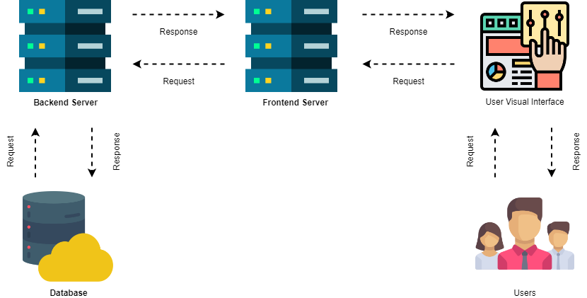

**Figure 2: System Architecture**

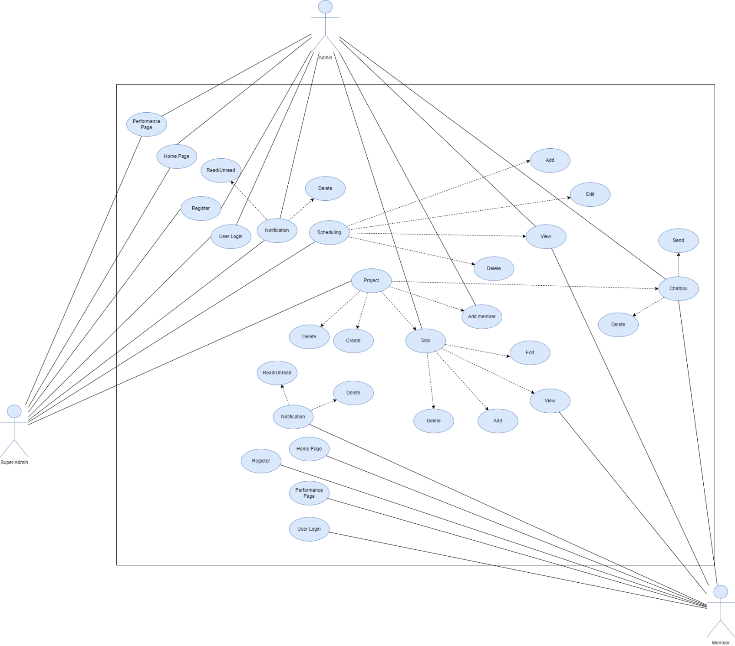This figure 2 shows the system architecture; there are two (2) web servers, two (2) visual interface, users, and database. The first (1st) server or the backend server is the one responsible for securing, storing, deletion, updating and retrieval of the data in the database, and the second (2nd) server or the frontend server is the one who responsible for the user interface, and the one who process user’s request before it goes to the backend server. The database is where the data is being stored, and users entity is the users who use the application.

**Figure 3: System Use Case Diagram**

This figure 3 shows the use case diagram, where the interaction of every actors are seen. It has (3) three actors: the admin, super admin, and member. The super admin is capable of login, registering, tracking the progress, have full access to schedule and project. The admin is capable of login, registering, track the progress, and can add member, and have full access to task, and can view schedule. The member is capable of login, registering, track the progress, project chat box and can view schedule, and task.

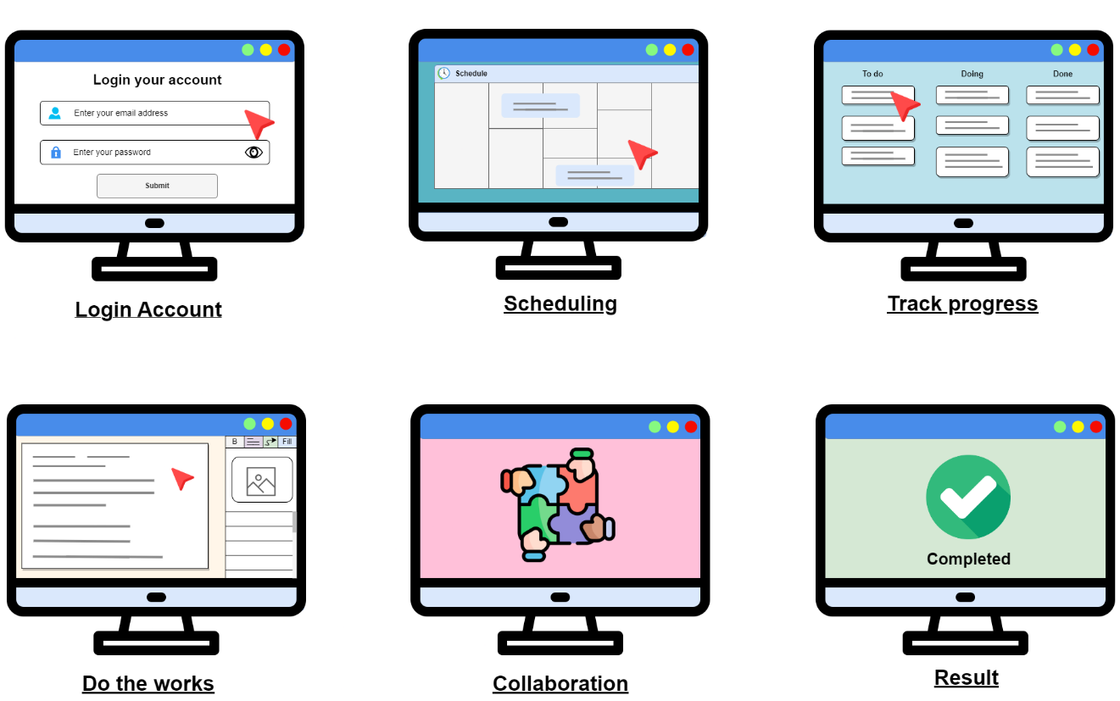

**Figure 4: System Storyboard**

The figure 4 shows the step by step process of the users in using the application. The first step is for the users to put in their valid information to log in. Afterwards, they can organize their appointments and task due dates in scheduling. The users also can also see how much they have progressed in all of their activities. The users can utilize the productivity tools provided by the application to complete their tasks. They can also collaborate with other users to help them finish their activities before the deadline. Lastly, they can analyze their result and performance by checking out the reports of their activities.

**Project Development**

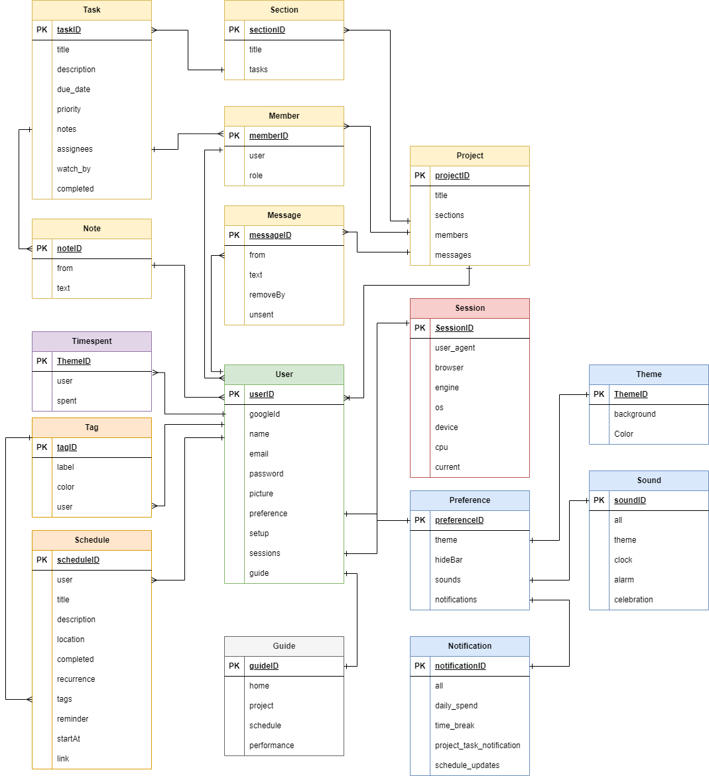

***Figure 5:* Entity Relationship Diagram**

The figure 5 shows the entity relationship diagram which contains sixteen (16) entities: the user, session, schedule, tag, guide, notification, preference, theme, sound, time spent, project, task, note, message, member, and section. Where the user preference, and guide, and has many schedule, tag and project. The preference entity has one theme, notification, and sound. The schedule has many tag. The project has many task, member, and message. The task has one project, and section, and the task has many notes, and assignee.

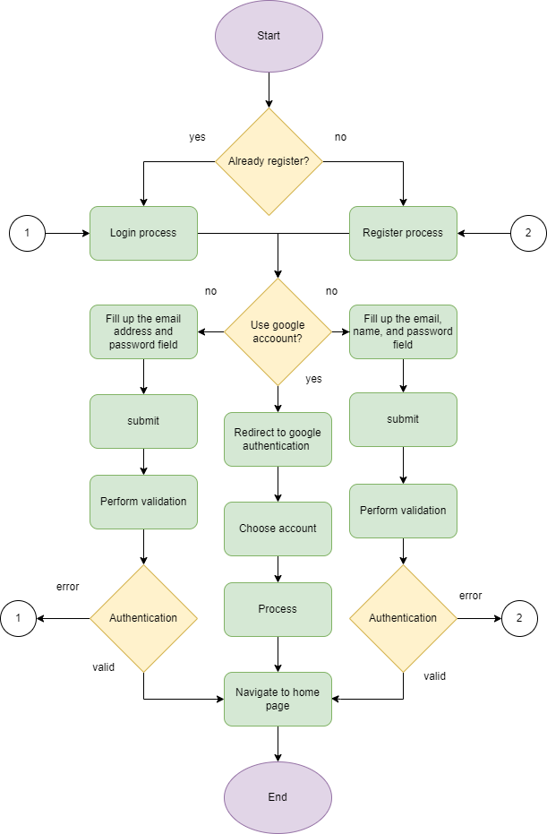

***Figure 6: Flowchart Authentication***

The figure 6 shows the authentication flowchart which begins with user. The application will verify the user after they input their email and password. If the user has a google account, they can use their account and proceed in processing the authentication and then the process ends. If the user is not yet registered and registered, they can manually provide the information and proceed to validation and then end the process.

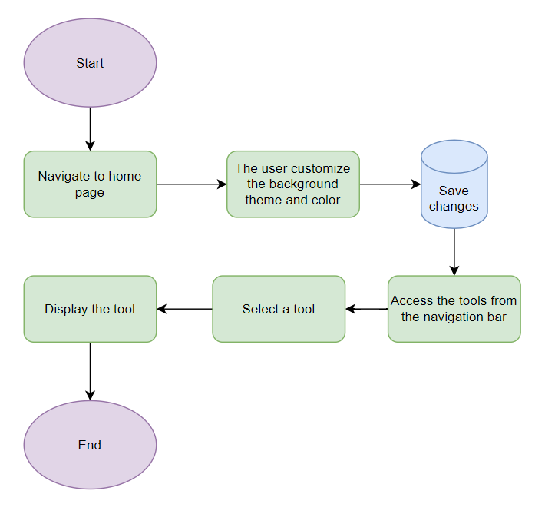

**Figure 7: Home Page Flowchart**

Figure 7 shows how users interact with the home page. It starts with them opening the home page. Then, they can change the background and color if they want. After that, they can save these changes. Users can also access different tools from the navigation bar. Once they choose a tool, it appears on the screen for them to use.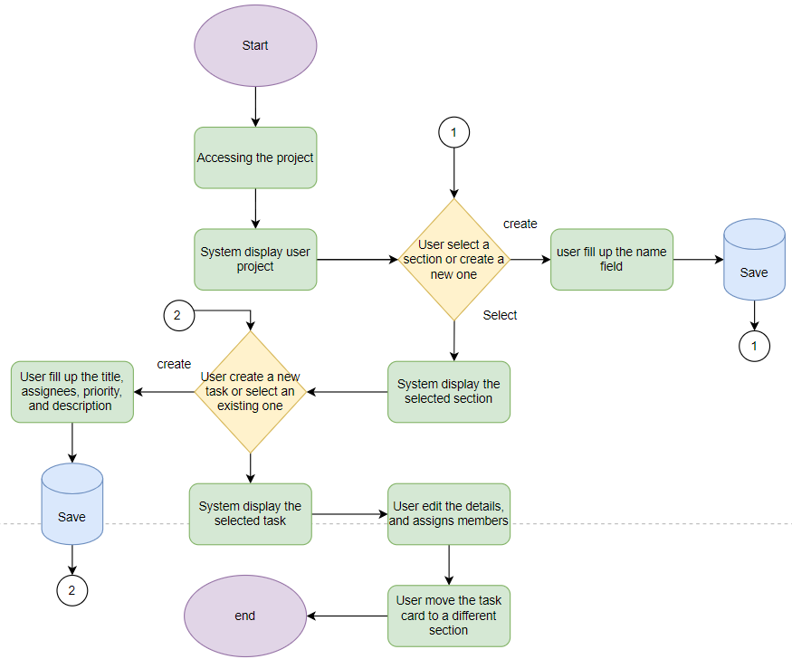

**Figure 8: Project page**

The Figure 8 shows the project page where the users begin in accessing and viewing project details. The user can choose a section or create a new one, then select or create a task. After that. The user can editing task details and assign members, they can also move tasks between sections for efficient management.

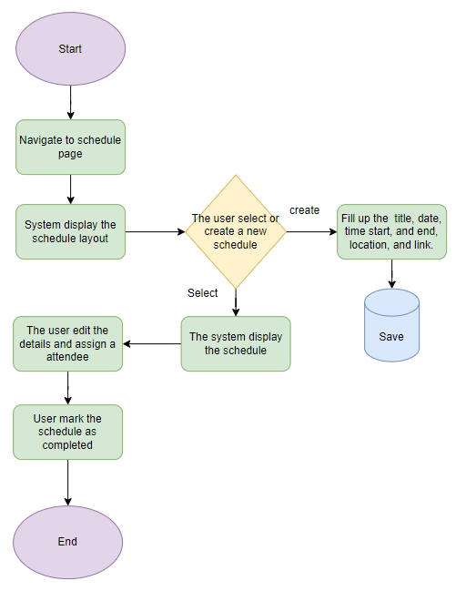

***Figure 9: Schedule page***

The Figure 9 shows the interaction of the user in schedule page. It starts with the navigation in schedule page. Then, the system displays the schedule layout. Users can pick an existing schedule or make a new one. Once selected, they can change details, add attendees, and mark it as completed.

**System Design and Development Model/Approach**

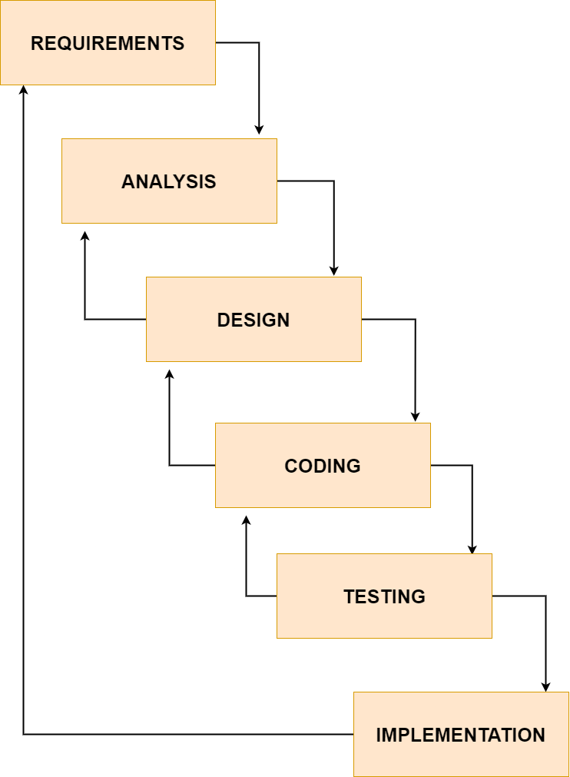

**Figure 10 Software Development Cycle**

The researchers will use the Software Development Cycle in order to create the system. The cycle contains six (6) parts: Requirements, Analysis, Design, Coding, Testing, and Implementation. Firstly, the developers must fulfill all the requirements to create the software. Next, they analyze the plan of action. Thirdly, they will execute the plan, by starting with formulating the design which the system will follow. Afterwards, the developers will begin in creating the software by coding, and then testing the program. After successful outputs, they will begin to implement or utilize the software that was made.

**Operation and Testing Procedure**

The instrument used to collect data was questionnaires. The questions in the questionnaires will be based by ISO 25010, which is a standard for software quality. It contains all the important characteristics to follow to create a functional and quality system. The software will be tested by showing it to the target users. They will then rate the system according to the criteria presented in the questionnaires.

**Evaluation Procedure**

The respondents that will evaluate the system are the target users, which are students. The system is also evaluated by faculties and experts which will ensure the quality of the software based on the perspective of a professional. They will rate and evaluate the system using the questionnaires provided to them, which contains criteria from ISO 25010 ensuring accurate evaluation for software quality.

**Population and Sample**

The respondents for the evaluation will be the target users, which are Arellano University – Jose Rizal Campus students. The evaluation will also be done by faculty, IT professionals and technical. The researchers will present the system to 50 students

**Research Instruments Used**

The research instruments used are questionnaires, which contains criteria from ISO 25010. These will be distributed to all the participants of this study.

**Statistical Treatment of Data**

To calculate the statistical average of respondents’ feedback, the researchers calculated the mean for each number in the questionnaire. The researchers used this formula to compute the mean:

$$\frac{\sum{x_{i}}}{n}$$

Where,

$x_{i}$ = ith variable

$n$ = Number of variables in the data set

**CHAPTER 4**

**RESULTS AND DISCUSSION**

This chapter presents the project description and structure, capabilities and limitation, projects test results and final evaluation.

**Project description**

The Efficiently web productivity system is aims to deliver a tools and friendly design that will enjoy and help the students for productivity. The system will give them a relaxing space where they can focus, and task management for an easy management for their given tasks, and schedules to help them plan their daily, weekly, and monthly plan, and statistics of their reports to make them aware of if they are being productive or not. The application also includes a real-time communication and collaborations, and tools that help them for being productive such as Pomodoro technique a time management technique, media card that allow the user to watch youtube video inside the application.

The system was developed using Javascript Language that allow us to develop a frontend and backend application. System also used frontend framework such as Nuxtjs that make the frontend more efficient, fast to developed, and allow the system to run via server side rendering, And UI library such as Vuetify that provides all necessary tools to build rich and engaging user experience. For storing data the system use MongoDB that removes the complexity of SQL base database, and make faster to retrieve, and secure the data.

**Project structure**

The system is divided in two user major components the guest and the authenticated user. The guest components is composed with five (5) pages which is the home, features, pricing, testimonial, and FAQ (Frequently Asked Question), that helps the user to get started and understand what will they get to the system. The authenticated user components is composed with four (4) pages which is the home, projects, schedules, and statistics, that’s gives the system services.

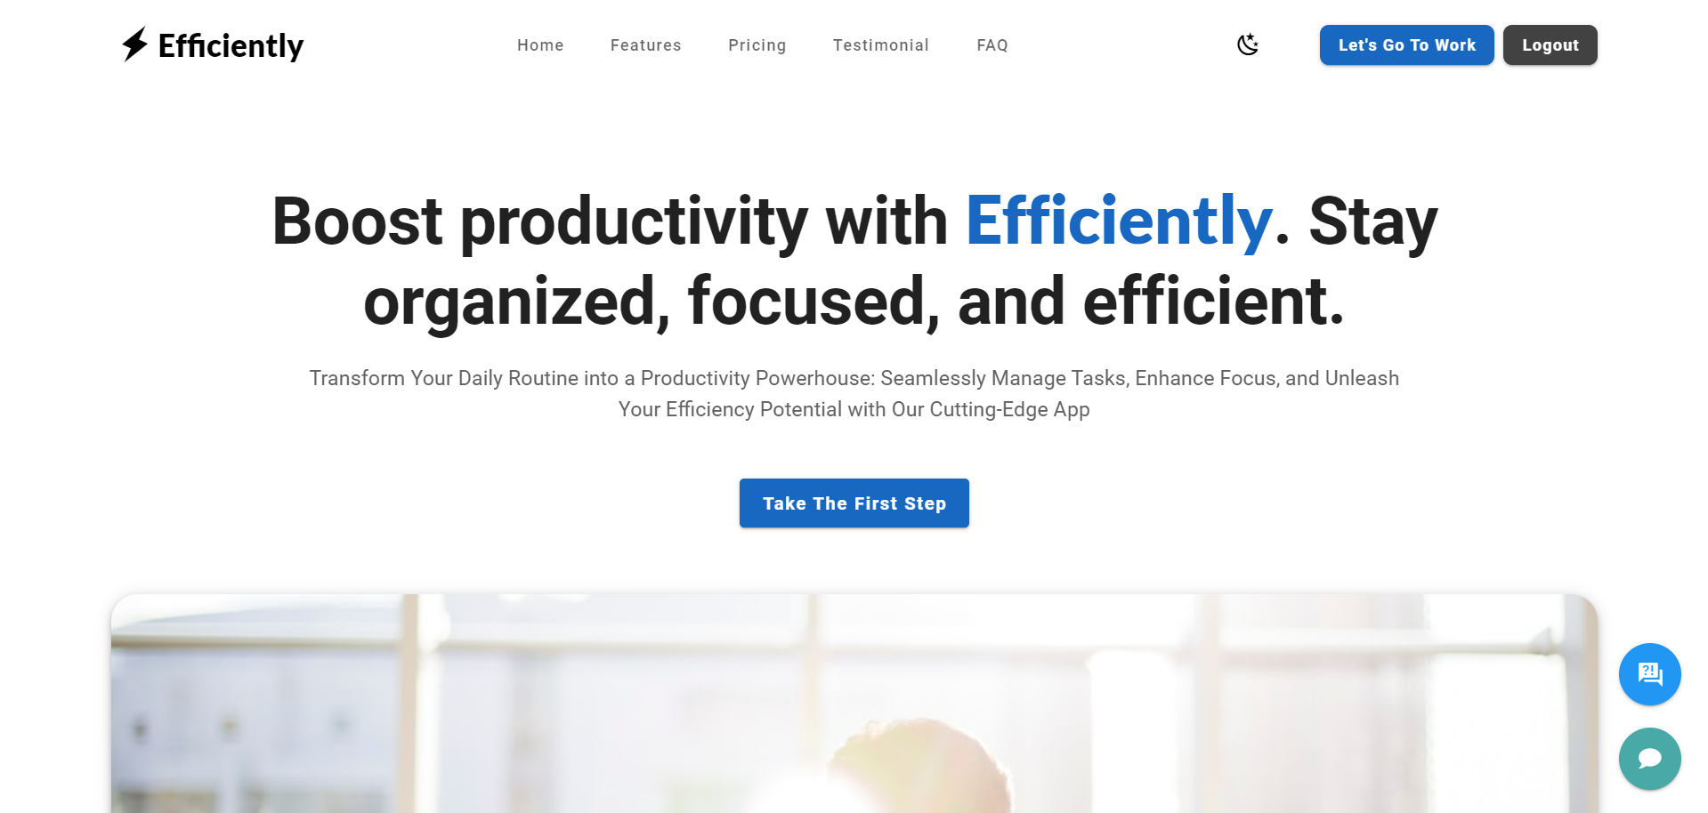**Project Screenshots**

***Figure 10: Landing Page***

The figure 10 show the landing page of the system where the user can get the information of the system and how to get started, it can navigate to features, pricing, testimonial and FAQ, login and register. It has the ability to change mode to dark.

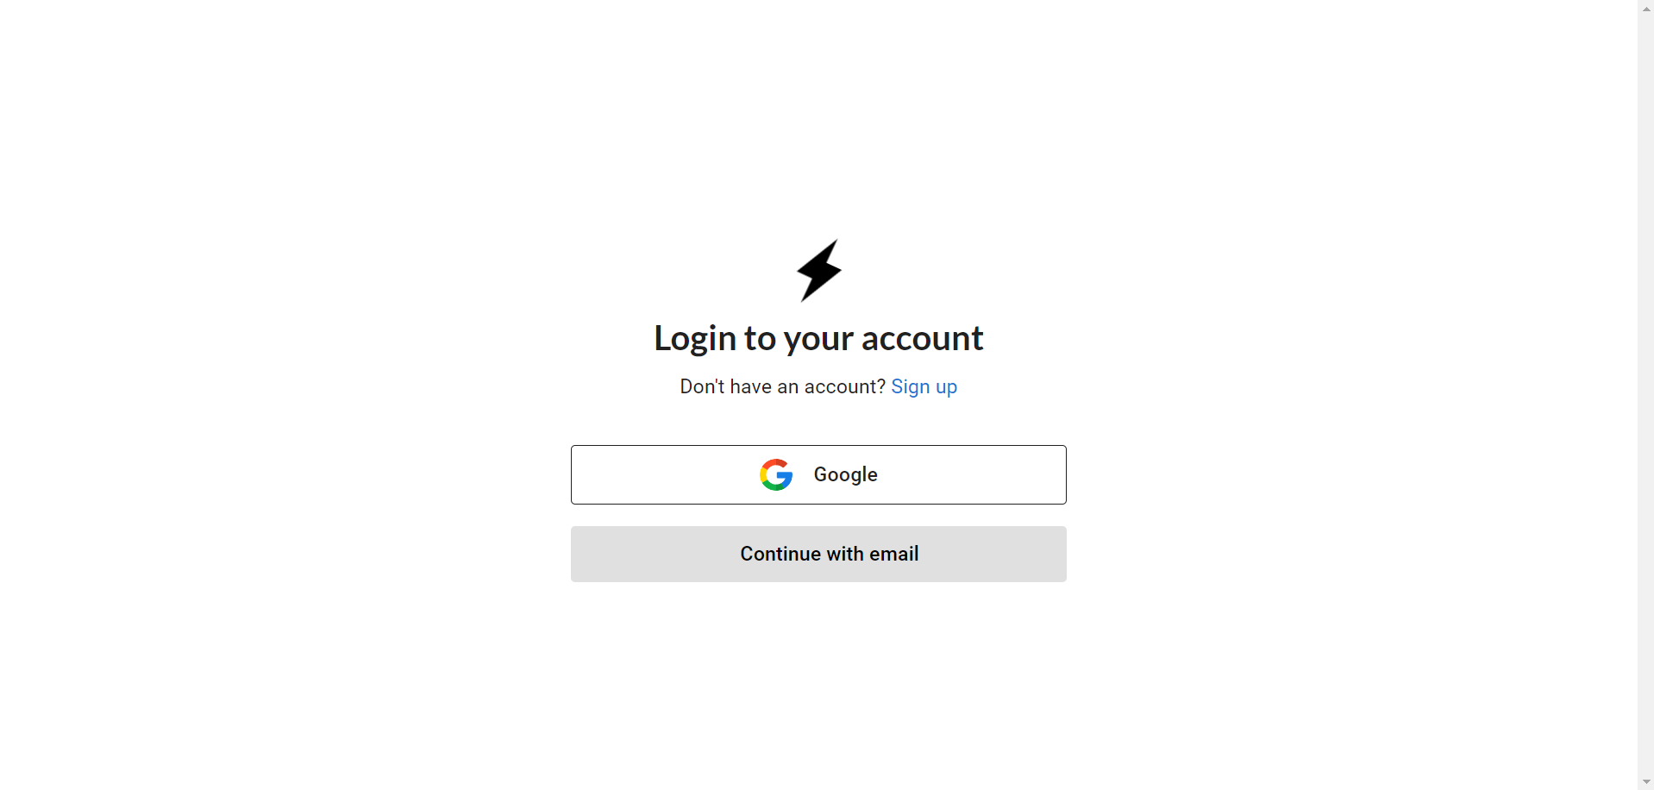

***Figure 11: Login Page***

The figure 11 show the login page where the page have a two options, the first option is google login where the user can login using their Gmail account for easy access, and the second option is continue with email, where the account is stored inside the system.

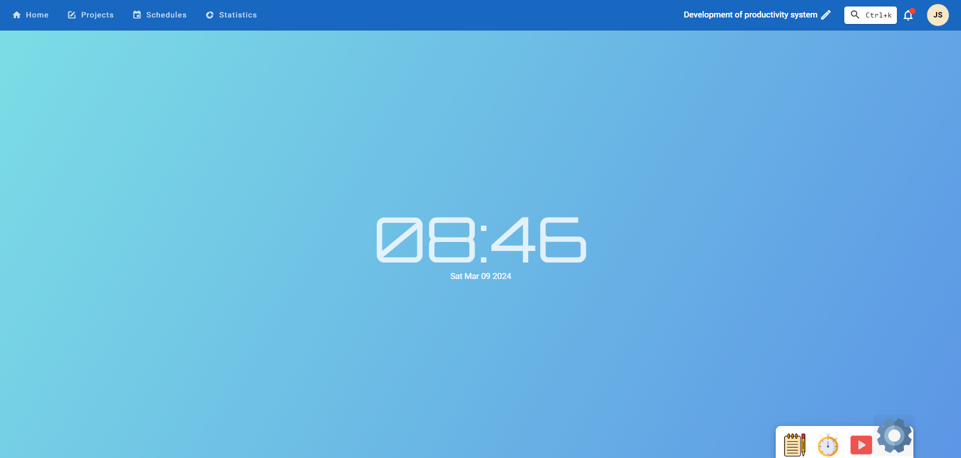

***Figure 12: Home Page***

The figure 12 show the home page of authenticated user, where the page gives user a relaxing background and customizable colors and theme.

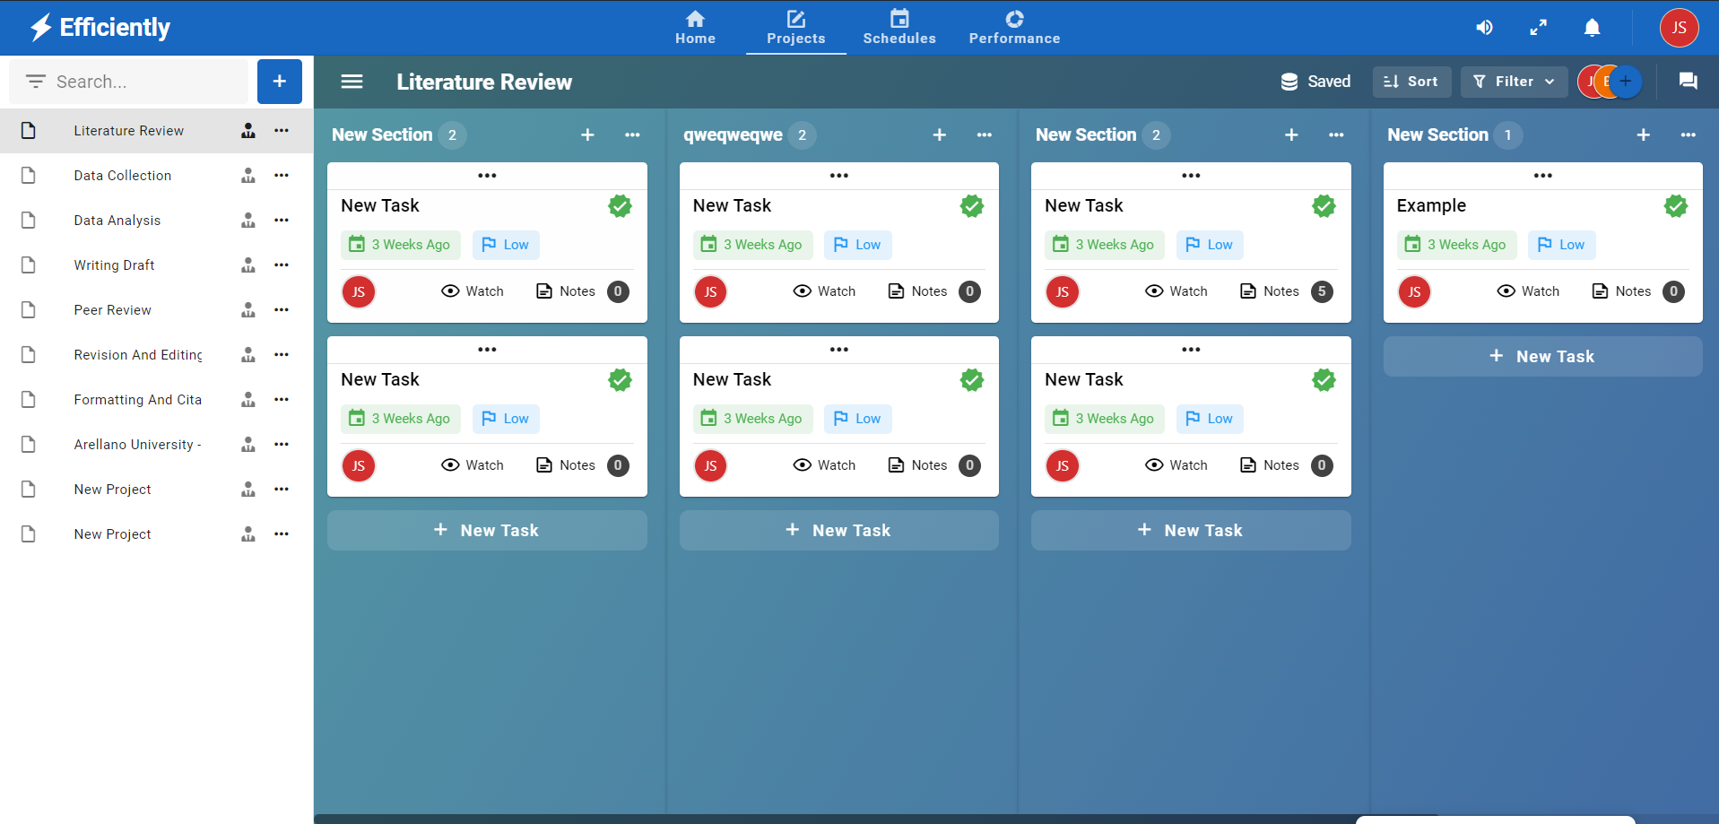

***Figure 13: Task management Page***

The figure 13 show the task management page where the users can easily manage the given tasks. The task management can create a new project, task, and section. The project, task and section is editable and deletable. This page is also allow the user to collaborate with other and navigator to the documentation section

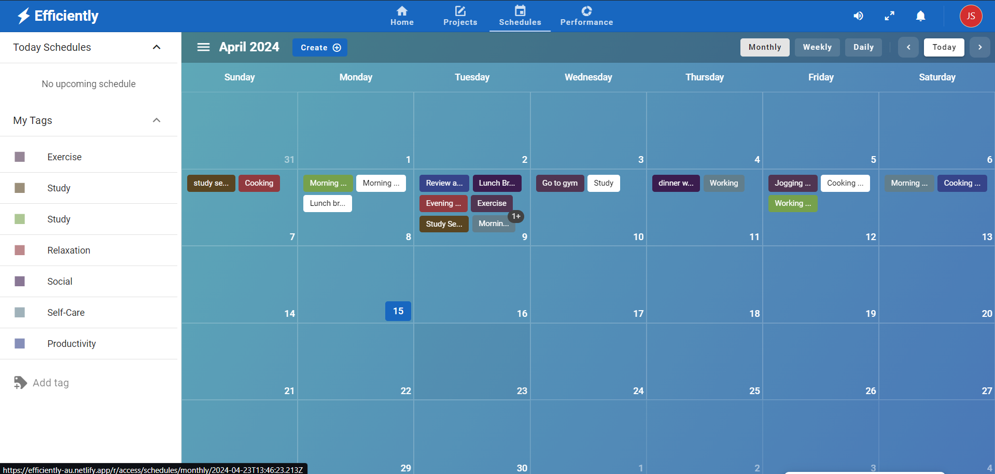

***Figure 14: Schedule Page***

The figure 14 show the schedule page where the users can assign their schedule in the table, the page allow the user to add tags to make it easy to filter and delete it. The page allow the user to change the calendar to daily, weekly, and monthly. The page also allow the user to assign a task for schedule and this task is checkable.

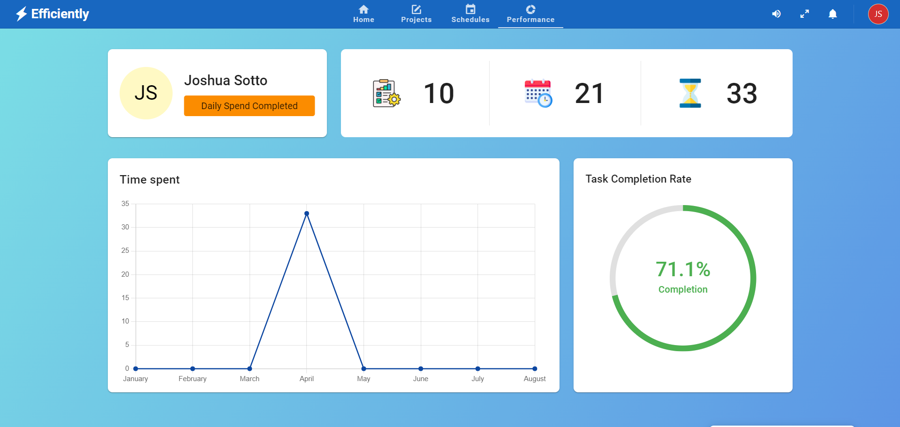

***Figure 15: Performance Page***

The figure 15 show the statistics page, where the users can see their reports. The users can see their progress, projects, and member progress. This page allow the users aware about their doing.

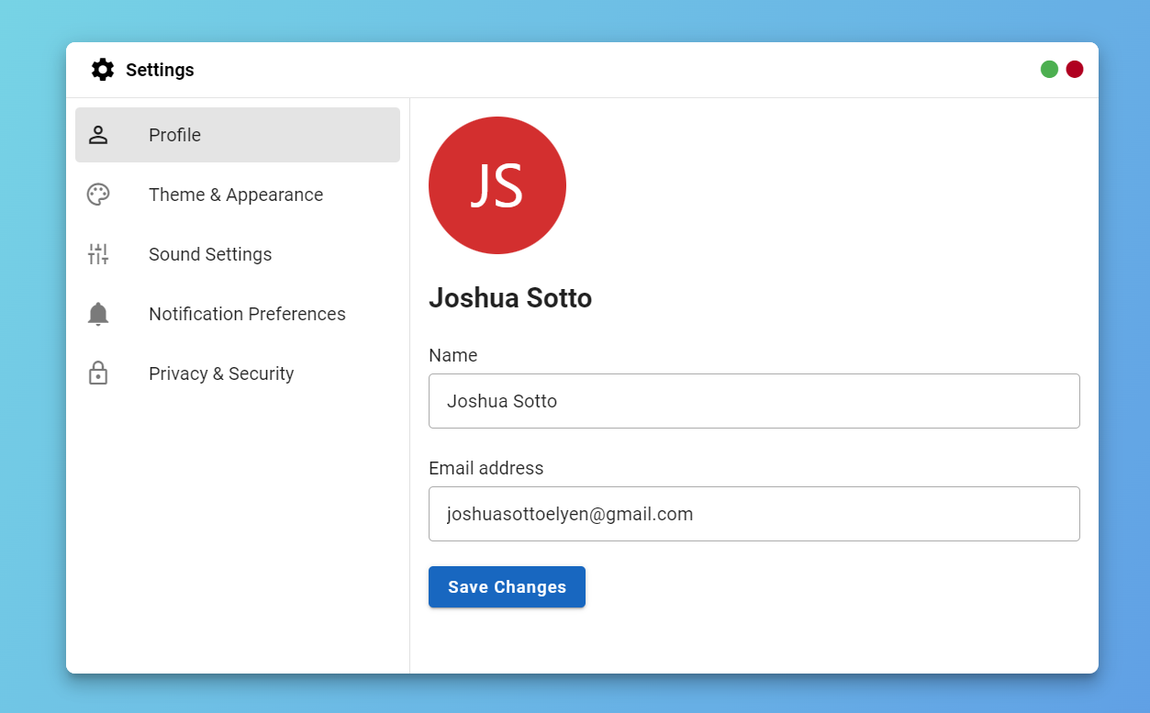

***Figure 16: Profile Setting***

The figure 16 show the settings card where it selected is profile, the profile setting is allow the edit information such as name, and email address. It’s has a button for save changes. 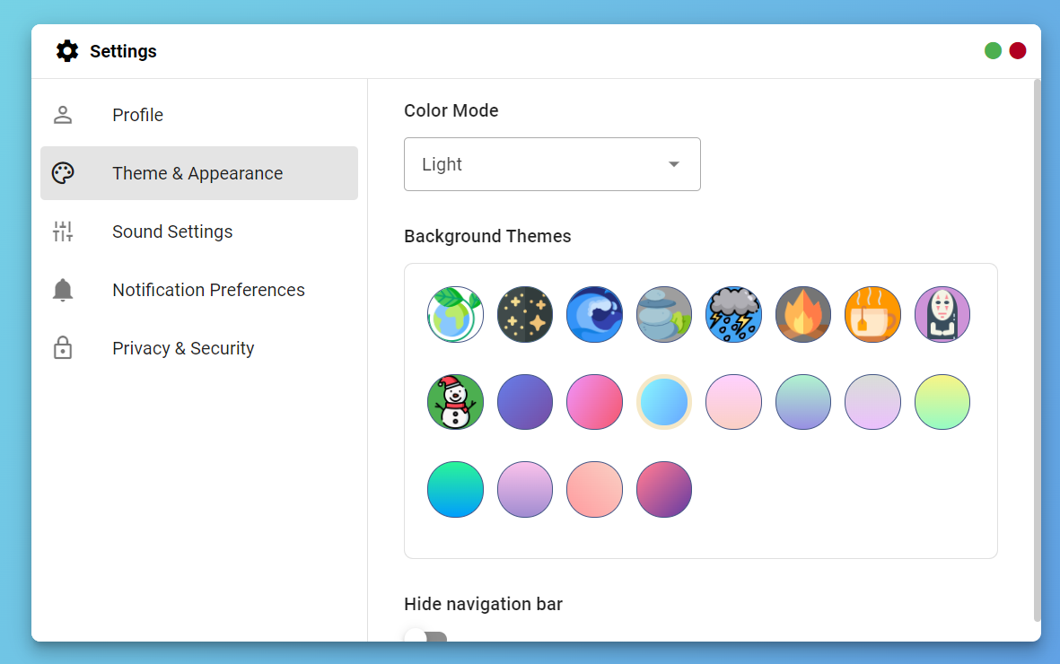

***Figure 17: Theme and Appearance Setting***

The figure 17 show the settings card for theme and appearance, where the user can customize the color mode for the user own preference, and the background theme, and hide the app bar.

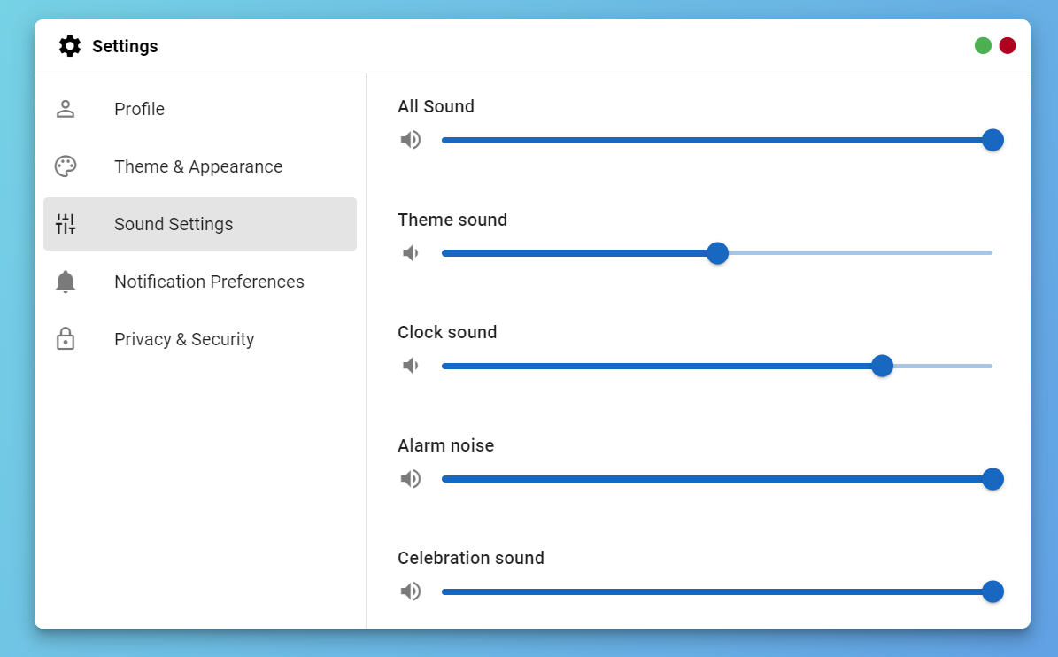

***Figure 18: Sound Setting***

The figure 18 show the sound setting, this allow the users to increase and decrease the sound of theme, clock, and alarm.

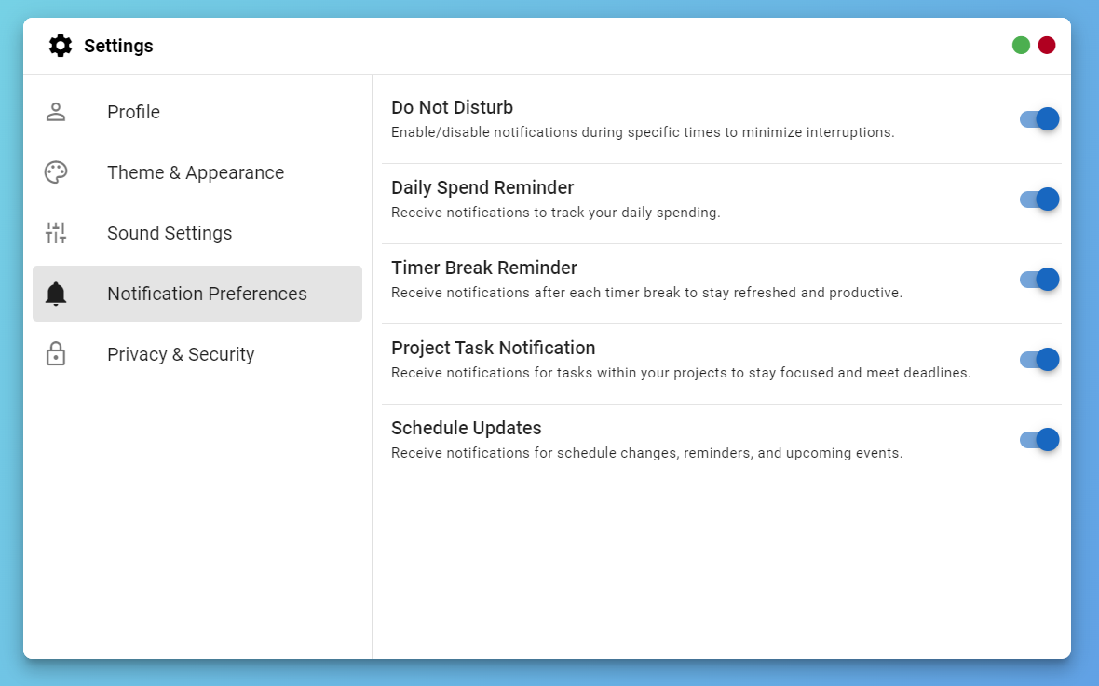

***Figure 19: Notification Setting***

The figure 19 show the notification setting, this allow the users to toggle the notification of specific feature such as daily spend, time break, project task, and schedule. This setting also allow the user to toggle do not disturb.

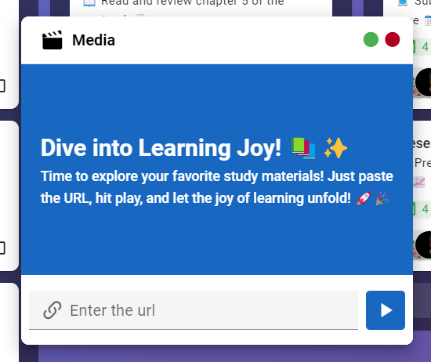

***Figure 20: Media Card***

The figure 20 show the media card tool where the users allow to watch a youtube video inside the application, the users need to copy a youtube URL, paste to text field and push the play button.

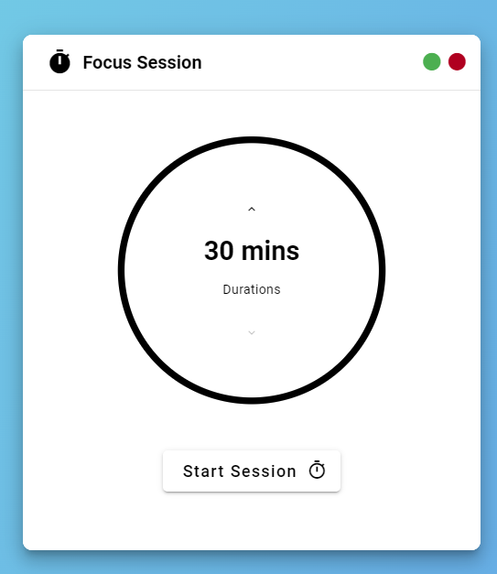

**Figure 21: Focus Session Card**

The figure 21 show the timer card tool where the tool help the user to focus using Pomodoro technique.

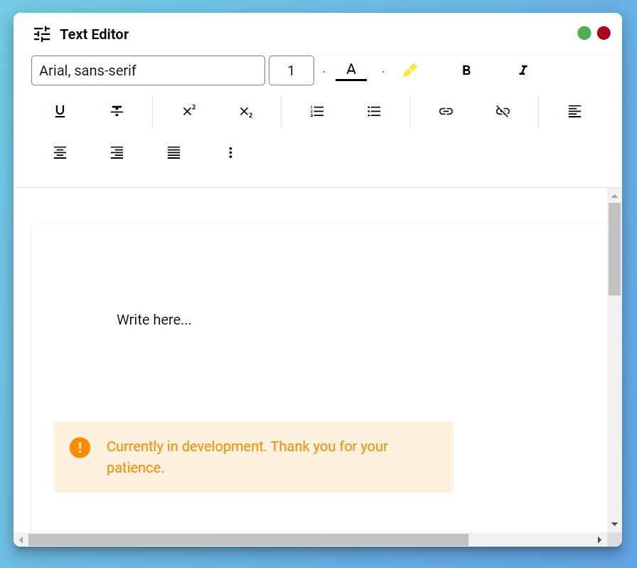

***Figure 22: Text Editor Card***

The figure 22 show the text editor card where the user can create his document, or take note.

**Table 1** – Test Results

|  |  |
| --- | --- |
| TEST CONDUCTED | BEHAVIOR |
| Presentable Background Image and Noise | The high-quality, calming visual and aural background of the system provides a digital environment that aids in the concentration of the user. |
| Customizable Background Image and Noise | The system’s array of background images, video, and audio provides a various selection that the user can choose from. |
| Alarm Feature Volume Intensity | The Alarm Feature’s volume is loud enough to successfully alert the user of their inactivity. The users are also capable of adjusting the volume to their specific preferences and needs. |
| Accuracy of Text Formatting and Modification in Text Editor | The text are accurately and correspondingly changing according to the users’ chosen adjustments. |
| User Authentication of the Log-In Feature | The system provides a Log-In page wherein the user must provide their username along with their password in order to access their account. |
| Flexibility of the Schedule Feature | The system allows user to input events, tasks, as well as task delegation to other users in the Schedule Feature. It also changes its format to Daily, Weekly, and Monthly according to the user’s preference. |
| Efficiency of Task Management Feature | The task management provides efficiency by providing 3 categories to the list of tasks: Pending Tasks, Ongoing Tasks, and Completed Tasks, This allows the user to clearly identify which tasks are completed, and which tasks require attention. |
| System Environment | The system is perfectly usable in web browsers such as Google Chrome, Firefox, Opera, and Microsoft Edge. |
| Reports Functionality and Performance Measurement | The application shows accurate result and allows user to perform in a productive environment. |

**Project Evaluation Results**

The performance of the system was evaluated in terms of the Functionality Suitability, Performance Efficiency, Usability, Reliability, and Security. The following were the results of the evaluation conducted with (30) thirty respondents who evaluated the project composed of (5) five Faculties, (5) five IT Expert and (20) twenty College Students of Arellano University Jose Rizal Campus.

To analyze the respondent feedback, the researchers utilize the formula for the mean to calculate the average of all the scores that were tallied in the questionnaires. In addition, the scores are sorted into different criteria – Functional Suitability, Performance Efficiency, Usability, Reliability, and Security. Here is the formula used to calculate the mean:



Subsequently, the calculated mean will be matched with their corresponding interpretation. Following that, the calculated mean are ranked from the highest score to the lowest score, 1 being the highest and 5 being the lowest. Here is the list of interpretation based on the mean:

4.50 - 5.00 Excellent

3.50 - 4.49 Very Good

2.50 - 3.49 Good

1.50 - 2.49 Fair

|  |  |  |
| --- | --- | --- |
| **Software Quality Indicators** | **Mean** | **Interpretation** |
| 1. Does the system’s functions fulfill user objectives? | 4.66 | Excellent |
| 2. Does the system provide correct and accurate results? | 4.6 | Excellent |
| 3. Does the system help the user accomplish tasks and objectives? | 4.62 | Excellent |
| 4. Does the system provide ease and convenience? | 4.7 | Excellent |
| **Overall Mean** | 4.64 | Excellent |

**Functional Suitability**

**Table 2: Functional Suitability Table**

Table 2 displays the outcomes regarding the Functional Suitability of the system. The first question scored 4.66, indicating it was rated as “Excellent”. Similarly, the second question scored 4.6, also considered “Excellent”. The third question scored 4.62 that indicate “Excellent”, lastly the fourth question scored the highest of 4.7 that interpret as “Excellent”. Overall, the average score for the Functional Suitability of the system is 4.64, indicating "Excellent" interpretation.

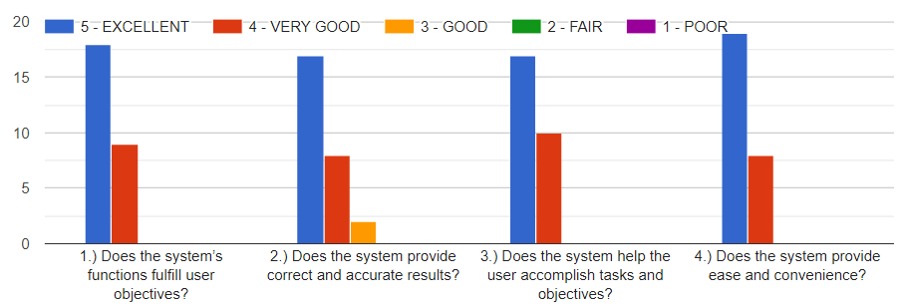

**Graph 1: Functional Suitability Graph**

Graph 1 shows functional suitability result, where all question shows that the majority of correspondent answer Excellent, rather than Very Good, Good, Fair, and Poor.

**Performance Efficiency**

|  |  |  |
| --- | --- | --- |
| 1. Is the response and processing time of the system in appropriate speed? | 4.59 | Excellent |
| 2. Are the resources used efficiently when performing its functions? | 4.63 | Excellent |
| 3. Does the system specifications meet the system requirements? | 4.51 | Excellent |
| **Overall Mean** | 4.58 | Excellent |

**Table 3: Performance Efficiency Table**

Table 3 displays the system's performance efficiency results. The first question received a score of 4.59, meaning that it was considered "Excellent." The second question received a score of 4.58, which is also regarded as "Excellent." The third question received a "Excellent" rating of 4.51. The system's overall Performance Efficiency score is 4.58, which indicates "Excellent" interpretation.

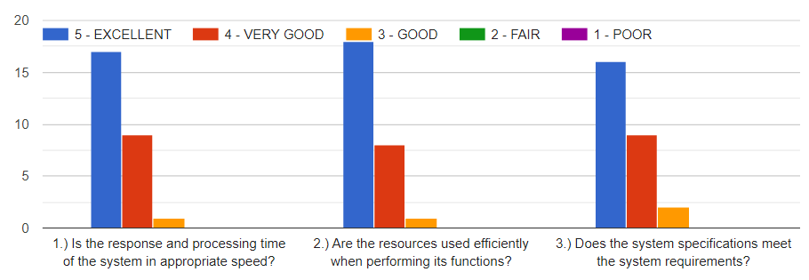

**Graph 2: Performance Efficiency Graph**

Graph 2 shows a performance efficiency result, where all questions indicate that most respondents chose to respond with an Excellent response over a Very Good, Good, Fair, or Poor one.

|  |  |  |
| --- | --- | --- |
| Is the system easy to use and operate? | 4.7 | Excellent |
| Is the system easy to understand? | 4.59 | Excellent |
| Is the system presentable? | 4.74 | Excellent |
| Will the users be able to learn the system alone? | 4.59 | Excellent |
| Does the system prevents users from making errors? | 4.73 | Excellent |
| **Overall Mean** | 4.67 | Excellent |

**Usability**

**Table 4: Usability Table**

Table 4 shows the usability results of the system. With a score of 4.7, the first question was rated as "Excellent." The second question was rated as "Excellent" as well, with a score of 4.59. The third question also received a "Excellent" rating of 4.74. With a score of 4.59, the fourth question was rated as "Excellent". With a rating of 4.73, the fifth question was rated as "Excellent". With an overall Usability score of 4.67, the system is interpreted as "Excellent".

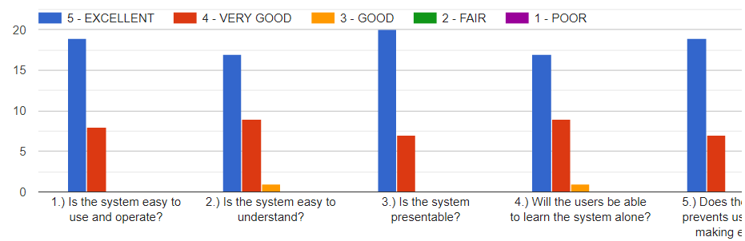

**Graph 3: Usability Graph**

Graph 3 demonstrates a usability result in which the majority of respondents selected an Excellent response over a Very Good, Good, Fair, or Poor one for all questions.

**Reliability**

|  |  |  |
| --- | --- | --- |
| Is the system available anytime? | 4.48 | Excellent |
| Is the system accessible when the user needs to use it? | 4.52 | Excellent |
| Can the system operate despite malfunction in hardware or software existence? | 4.63 | Excellent |
| In an event of interruption or disaster, can the system recover itself to an operable state? | 4.5 | Excellent |
| **Overall Mean** | 4.53 | Excellent |

**Table 5: Reliability Table**

Table 5 shows the system's reliability results. The first question received a score of 4.48, meaning it was rated as "Very Good." The second question received a score of 4.52, meaning it was also rated as "Excellent". Additionally, the third question was rated as "Excellent" with a 4.63 score. The fourth question received a "Excellent" rating of 4.5. The system receives an overall reliability score of 4.53, which is considered "Excellent".

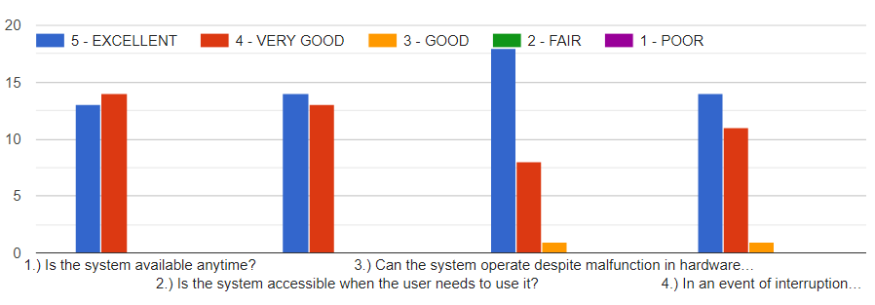

**Graph 4: Reliability Graph**

Graph 4 illustrates a usability result where most respondents chose Excellent over Very Good, Good, Fair, or Poor for every question.

**Security**

|  |  |  |
| --- | --- | --- |
| Is the data only accessible to users with authorized access? | 4.63 | Excellent |
| Does the system prevent unauthorized access and modification of data? | 4.4 | Very Good |
| Can the users’ actions be uniquely traced back to them? | 4.4 | Very Good |
| Can the identity of the user be proven to be as them? | 4.48 | Very Good |
| **Overall Mean** | 4.46 | Very Good |

**Table 6: Security Table**

Table 6 shows the security results of the system. With a score of 4.63, the first question was rated as "Excellent," and with a score of 4.4, the second question was rated as "Very Good." Furthermore, the third question received a score of 4.4, rating it as "Very Good". The fourth question scored 4.48, earning a "Very Good" rating. With an overall reliability score of 4.46, the system is rated as "Very Good".

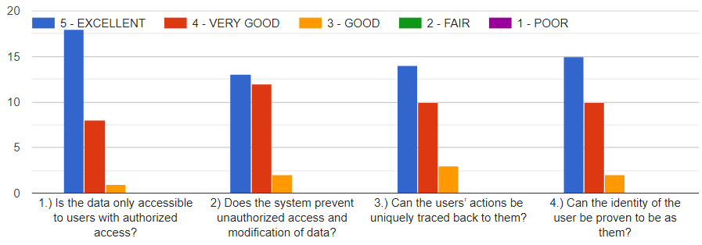

**Graph 5: Security Graph**

Graph 5 shows a security result in which the majority of respondents selected Very Good for every question instead of Excellent, Good, Fair, or Poor.

**Summary of Evaluation Results**

|  |  |  |  |
| --- | --- | --- | --- |
| **CRITERIA** | **MEAN** | **INTERPRETATION** | **RANK** |
| Usability | 4.67 | Excellent | 1 |
| Functional Suitability | 4.64 | Excellent | 2 |
| Performance Efficiency | 4.58 | Excellent | 3 |
| Reliability | 4.53 | Excellent | 4 |
| Security | 4.46 | Very Good | 5 |
| Overall Mean | 4.6 | Excellent |  |

**Table 7: Summary of the evaluation results**

Table 7 shows the summary of the evaluation results. The evaluation being executed using survey questionnaires. According to the calculated mean and its corresponding interpretation, the overall feedback for the system is “Excellent”, with the overall mean of 4.6. Out of all the criteria, Usability achieved the highest satisfaction rate with computed mean of 4.67, and the ranking of 1. The second in rank is Functional Suitability with the mean of 4.64. It is then followed by Performance Efficiency with the mean of 4.58, then with Reliability with the mean of 4.53. Lastly, Security is placed on the lowest with the mean of 4.46. On Security criteria, the system is rated “Very Good” for the sub-criteria of confidentiality, integrity, accountability, and authenticity. On Reliability, the system is rated “Very Good”, for the sub-criteria of availability, accessibility, fault tolerance, and recoverability. On Usability, the system is rated “Excellent” for the sub-criteria of operability, user interface aesthetics, learnability, and user error protection. On Performance Efficiency, the system is rated “Excellent” for the sub-criteria of time-behavior, resource utilization, and capacity. On Functional Suitability criteria, the system is rated “Excellent” for the sub-criteria of completeness, correctness, appropriateness, and convenience. This indicates that the system provides the function and features that the users need.

**Chapter 5**

**SUMMARY OF FINDINGS, CONCLUSIONS,**

**AND RECOMMENDATIONS**

This chapter presents the summary of findings, the conclusions drawn, and the recommendations of the study based on the results of testing and evaluation, comments and suggestions given by the panel of evaluators.

**Summary of findings**

Through testing and evaluation of the system's quality, the researchers discovered the following outcomes. Firstly, the application, named Efficiently web productivity system, aligned properly with its expected functional quality. This was shown through its user-friendly design, which contributed to the application's ease of use and enhancing student's productivity.

The application showcased various features which caters to the needs of its users. It offers a relaxing and productive online environment, which helps the users focus on their activities. Moreover, the application also exhibits various management features which helps the users organize their tasks. The application also has schedule management attributes which aids the users in planning their activities into daily, weekly and monthly format.

Efficiently application also displays detailed productivity and progress reports. Knowing this will help the user understand and visualize their productivity level.

The application showcased effective system architecture. It uses JavaScript for frontend and backend application development to ensure excellent software quality. It utilized Nuxr.js to aid in frontend development, running on the server rendering to optimize the user request page. Veutify helps in the development of a user friendly interface. Additionally, MongoDB offers data storage that is secured and quick data retrieval.

Test results indicate that all modules operate as intended according to the design specifications. The system received an evaluation of "Excellent," with an average score of 4.57, demonstrating that it successfully achieves its intended purpose of assessing student message contributions.

**Conclusions**

In consideration of the objectives of the study and the result of the result of the testing and evaluation carried out, the following conclusions were derived.

1. The Efficiently web productivity system was successfully developed such that:
   1. It provided users a collection of calming and relaxing background visuals and auditory sounds. It also provided a tools that help the student for their productivity such as text editor, to do list card, media card, and timer.
   2. The system allowed the user to manage their task using the task management features, it is also allowed the user to collaborate with other user.
   3. The system allowed the user to manage their plan and goal using the schedule management feature, it is also allowed the user to invite attendee, alarm upcoming schedule, and recurrence of the schedule.
   4. It can generate a reports of the user usage and completion that allow the user to monitor their performance.
2. The application was successful created using a Postman, Visual Studio Code, Node.js, and MongoDB, and it deployed using hosting provider such as Netflify and Render.
3. The overall system was successfully tested for functionality of each module and accuracy of assessment; and
4. The performace of the system was rated “excellent” by the evaluators. This proves that it can help the user for their productivity.

**Recommendations**

Based on the summary of findings and conclusions the following are recommended:

1. The productivity application user interface support only a desktop device. It may be a good to make this application support the mobile application
2. Integration of scanner for the potential malicious image and files.
3. Optimize the relaxing background so it make the background display faster.
4. Improve the performance report, make it more entertaining.

**Topical outline**

**Review Related Literature**

Title of the Project Study:

Development of a Web-based Productivity System

1. What is productivity?

Importance of productivity

* + 1. Increased productivity
    2. Businesses also benefit from increased productivity
    3. Increasing productivity is essential for long-term success.

Ways to improve productivity

* + 1. Reminders will keep a person on track with the activity they are doing
    2. Regularly reviewing goals helps you understand and monitor all your objectives
    3. Regularly reviewing goals helps you understand and monitor all your objectives.
    4. Using productivity applications and software is helpful in increasing efficiency, accuracy and collaborations.
    5. For individuals, here are productivity tactics to use to improve overall efficiency
    6. Taking breaks allows a person to physically and mentally rest, and recuperate their energy
    7. Delegation is the act of redirecting tasks to other team members
    8. Distractions increase stress levels, adds to fatigue, and a leading factor to losing control in their tasks

2. The rise of online learning

3. The advantages of online learning

4. The Disadvantages of Online Learning

Lack of Motivation in Students

5. Poor time management

Online Distractions

**Appendix A**

Evaluation Instrument

for the

Web Based Productivity System

**DEVELOPMENT OF WEB-BASED PRODUCTIVITY SYSTEM IN ARELLANO UNIVERSITY – JOSE RIZAL CAMPUS**

1. Respondent’s Profile:

Name (Optional): Date:

1. Category of Respondents:

 CS FACULTY CS STUDENT’S

 IT / CS EXPERTS

1. Put a Check mark (✔️) on the column opposite its indicators to determine the extent in which the following functional suitability, performance efficiency, usability, reliability, and security are used in the developed system. The columns are numbered according to the degree of your belief with the following interpretation:

**Numerical Rating: Equivalent:**

5 Excellent

4 Very Good

3 Good

2 Fair

1. Poor

|  |  |  |  |  |  |  |
| --- | --- | --- | --- | --- | --- | --- |
|  | **INDICATORS** | 5 - E | 4 - VG | 3 - G | 2 - F | 1 - P |
|  | **FUNCTIONAL SUITABILITY** |  |  |  |  |  |
| 1.) | Does the system’s functions fulfill user objectives? |  |  |  |  |  |
| 2.) | Does the system provide correct and accurate results? |  |  |  |  |  |
| 3.) | Does the system help the user accomplish tasks and objectives? |  |  |  |  |  |
| 4.) | Does the system provide ease and convenience? |  |  |  |  |  |
|  | **PERFORMANCE EFFICIENCY** |  |  |  |  |  |
| 1.) | Is the response and processing time of the system in appropriate speed? |  |  |  |  |  |
| 2.) | Are the resources used efficiently when performing its functions? |  |  |  |  |  |
| 3.) | Does the system specifications meet the system requirements? |  |  |  |  |  |
|  | **USABILITY** |  |  |  |  |  |
| 1.) | Is the system easy to use and operate? |  |  |  |  |  |
| 2.) | Is the system easy to understand? |  |  |  |  |  |
| 3.) | Is the system presentable? |  |  |  |  |  |
| 4.) | Will the users be able to learn the system alone? |  |  |  |  |  |
| 5.) | Does the system prevents users from making errors? |  |  |  |  |  |
|  | **RELIABILITY** |  |  |  |  |  |
| 1.) | Is the system available anytime? |  |  |  |  |  |
| 2.) | Is the system accessible when the user needs to use it? |  |  |  |  |  |
| 3.) | Can the system operate despite malfunction in hardware or software existence? |  |  |  |  |  |
| 4.) | In an event of interruption or disaster, can the system recover itself to an operable state? |  |  |  |  |  |
|  | **SECURITY** |  |  |  |  |  |
| 1.) | Is the data only accessible to users with authorized access? |  |  |  |  |  |
| 2) | Does the system prevent unauthorized access and modification of data? |  |  |  |  |  |
| 3.) | Can the users’ actions be uniquely traced back to them? |  |  |  |  |  |
| 4.) | Can the identity of the user be proven to be as them? |  |  |  |  |  |

What can you recommend to make the system more effective?

**Summary: Sum:**

a. FUNCTIONAL SUITABILITY ______

b. PERFORMANCE EFFICIENCY ______

c. USABILITY ______

d. RELIABILITY ______

e. SECURITY ______

**Total Score:** _______

**Appendix B**

**SUMMARY OF EVALUATION BY THE RESPONDENTS**

|  |  |  |
| --- | --- | --- |
| **Software Quality Indicators** | **Mean** | **Interpretation** |
| **A. FUNCTIONAL SUITABILITY** |  |  |
| 1. Does the system’s functions fulfill user objectives? | 4.66 | Excellent |
| 2. Does the system provide correct and accurate results? | 4.6 | Excellent |
| 3. Does the system help the user accomplish tasks and objectives? | 4.62 | Excellent |
| 4. Does the system provide ease and convenience? | 4.7 | Excellent |
| **Overall Mean** | 4.64 | Excellent |
| **B. PERFORMANCE EFFICIENCY** |  |  |
| 1. Is the response and processing time of the system in appropriate speed? | 4.59 | Excellent |
| 2. Are the resources used efficiently when performing its functions? | 4.63 | Excellent |
| 3. Does the system specifications meet the system requirements? | 4.51 | Excellent |
| **Overall Mean** | 4.58 | Excellent |
| **USABILITY** |  |  |
| Is the system easy to use and operate? | 4.7 | Excellent |
| Is the system easy to understand? | 4.59 | Excellent |
| Is the system presentable? | 4.74 | Excellent |
| Will the users be able to learn the system alone? | 4.59 | Excellent |
| Does the system prevents users from making errors? | 4.73 | Excellent |
| **Overall Mean** | 4.67 | Excellent |
| **RELIABILITY** |  |  |
| Is the system available anytime? | 4.48 | Excellent |
| Is the system accessible when the user needs to use it? | 4.52 | Excellent |
| Can the system operate despite malfunction in hardware or software existence? | 4.63 | Excellent |
| In an event of interruption or disaster, can the system recover itself to an operable state? | 4.5 | Excellent |
| **Overall Mean** | 4.53 | Excellent |
| **SECURITY** |  |  |
| Is the data only accessible to users with authorized access? | 4.63 | Excellent |
| Does the system prevent unauthorized access and modification of data? | 4.4 | Very Good |
| Can the users’ actions be uniquely traced back to them? | 4.4 | Very Good |
| Can the identity of the user be proven to be as them? | 4.48 | Very Good |
| **Overall Mean** | 4.46 | Very Good |

**Appendix C**

**Web based**

**Productivity System**

**User’s Manual**

**Getting Started**

1. Launch your preferred web browser (like Chrome, Firefox, Safari, etc.) on your computer.
2. Input the <https://efficiently-au.netlify.app> to the search field, and submit. The output shown will be as follows:

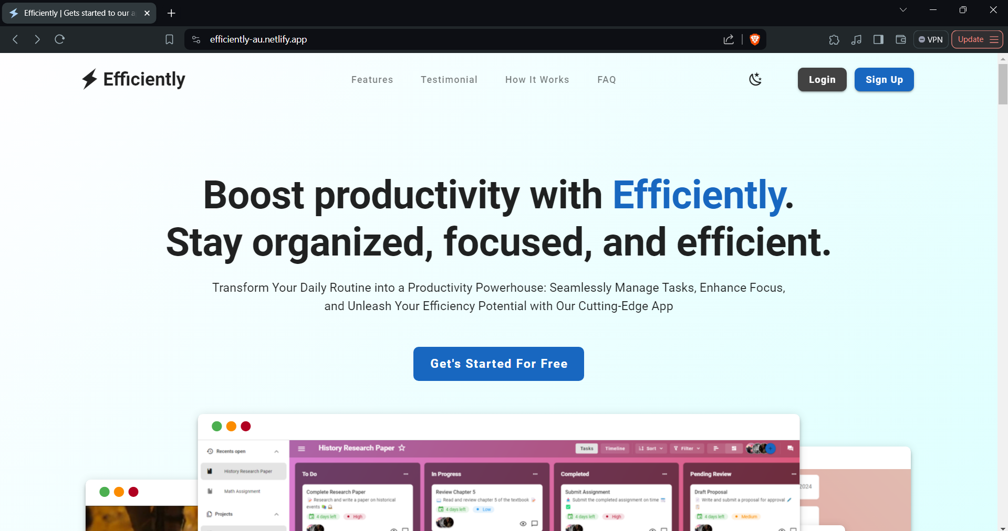

1. Click the sign up button (we consider you as a new user)
2. There is two option use our own authentication or the google authentication. If the google authentication choose your account, then completed. If our own authentication, fill up the name, email, password, and password confirmation. Once it’s all filled up, click the create account button.

## 

1. After the authentication the output will show the same as the picture below. To begin your journey click the button.

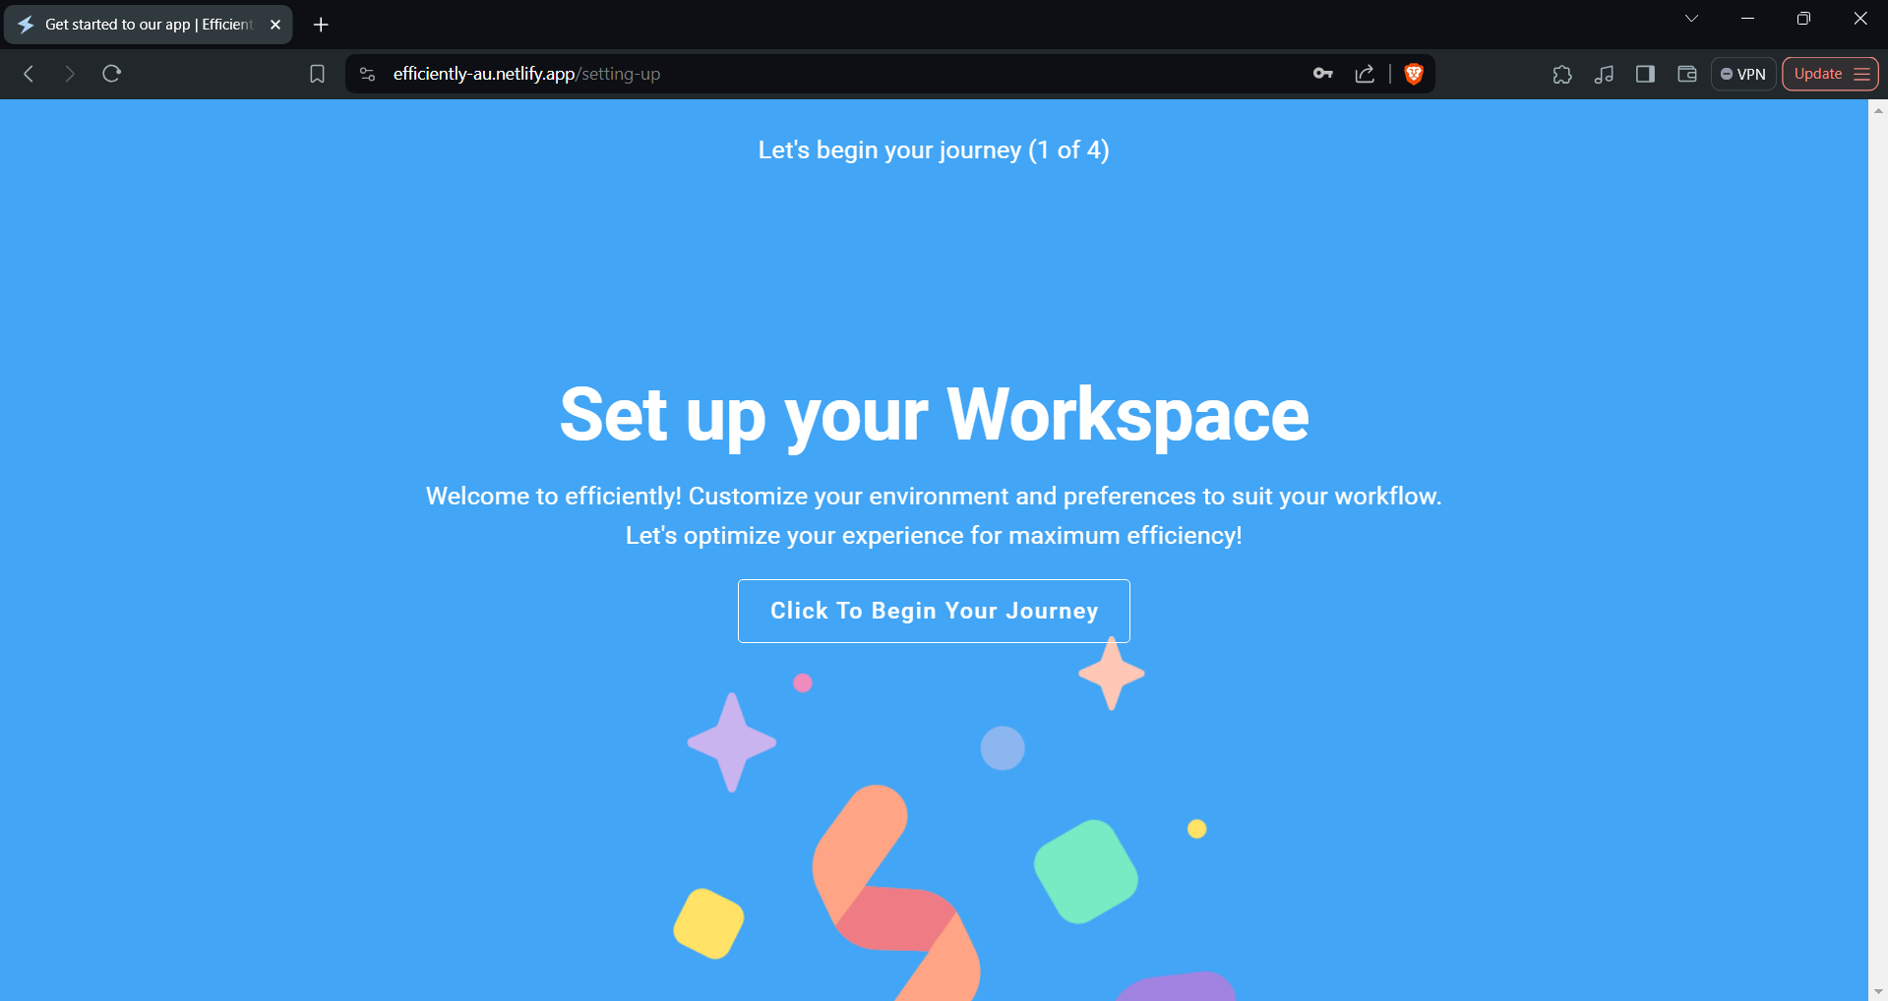

1. Select your preferred background

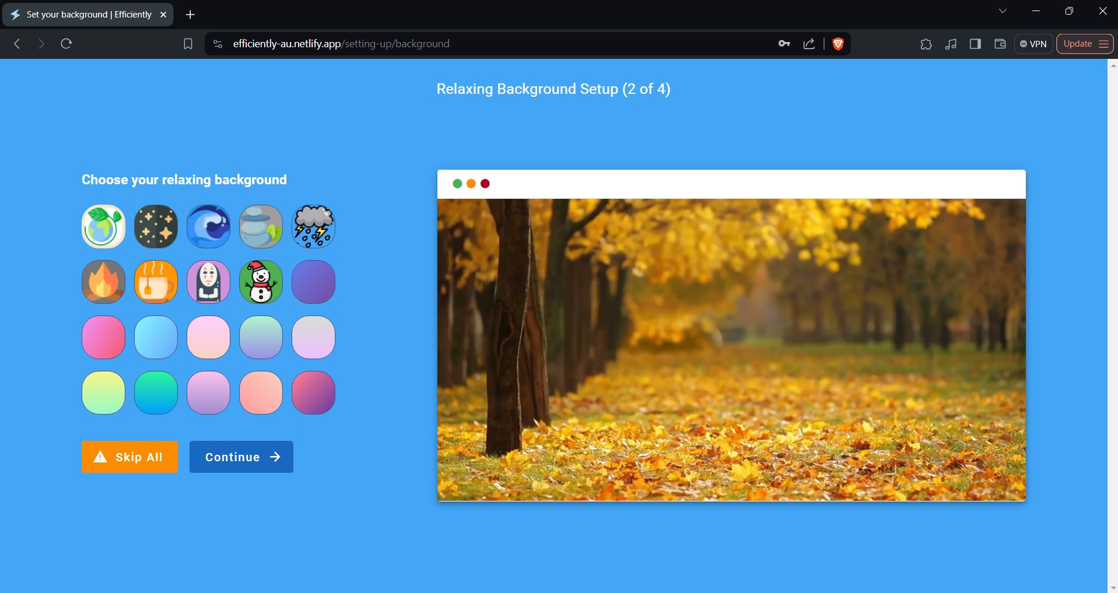

1. Filled up the project name, and submit. Create at least three tasks (optional), then click the continue button.

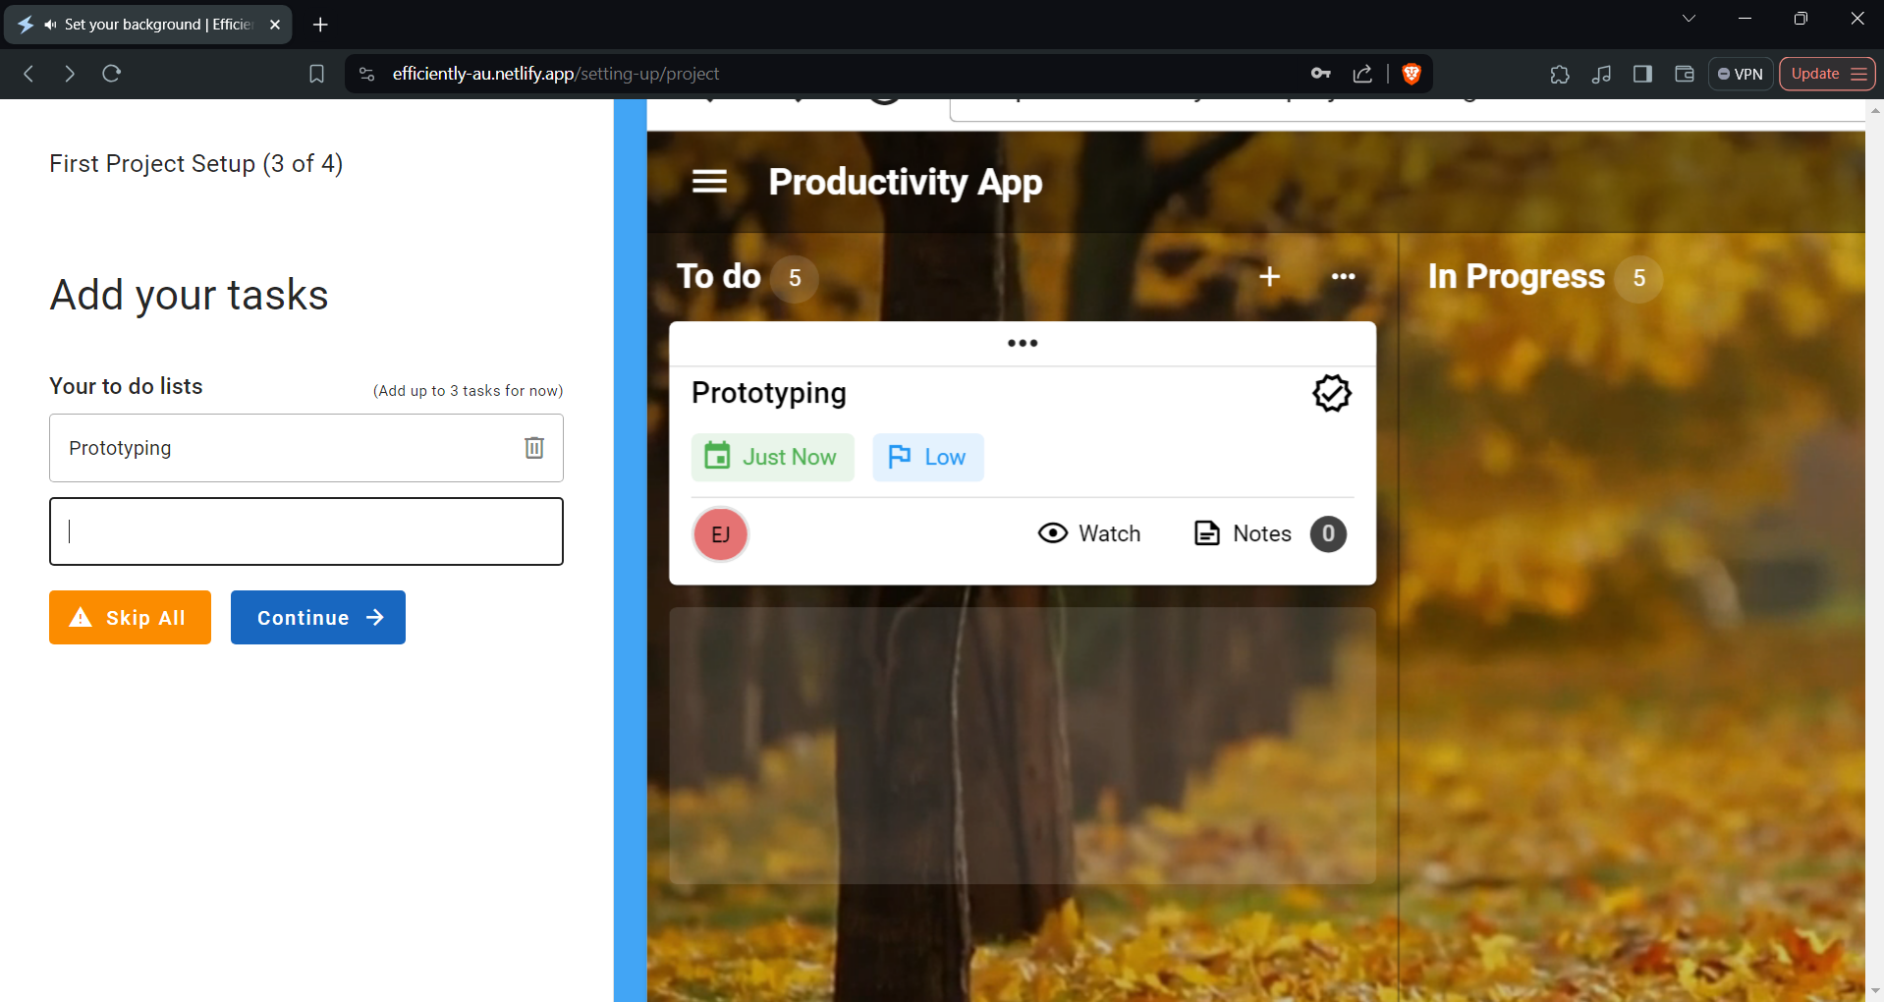

1. Select Your Daily Routine Recommendations (optional), then click the finalize setup button.

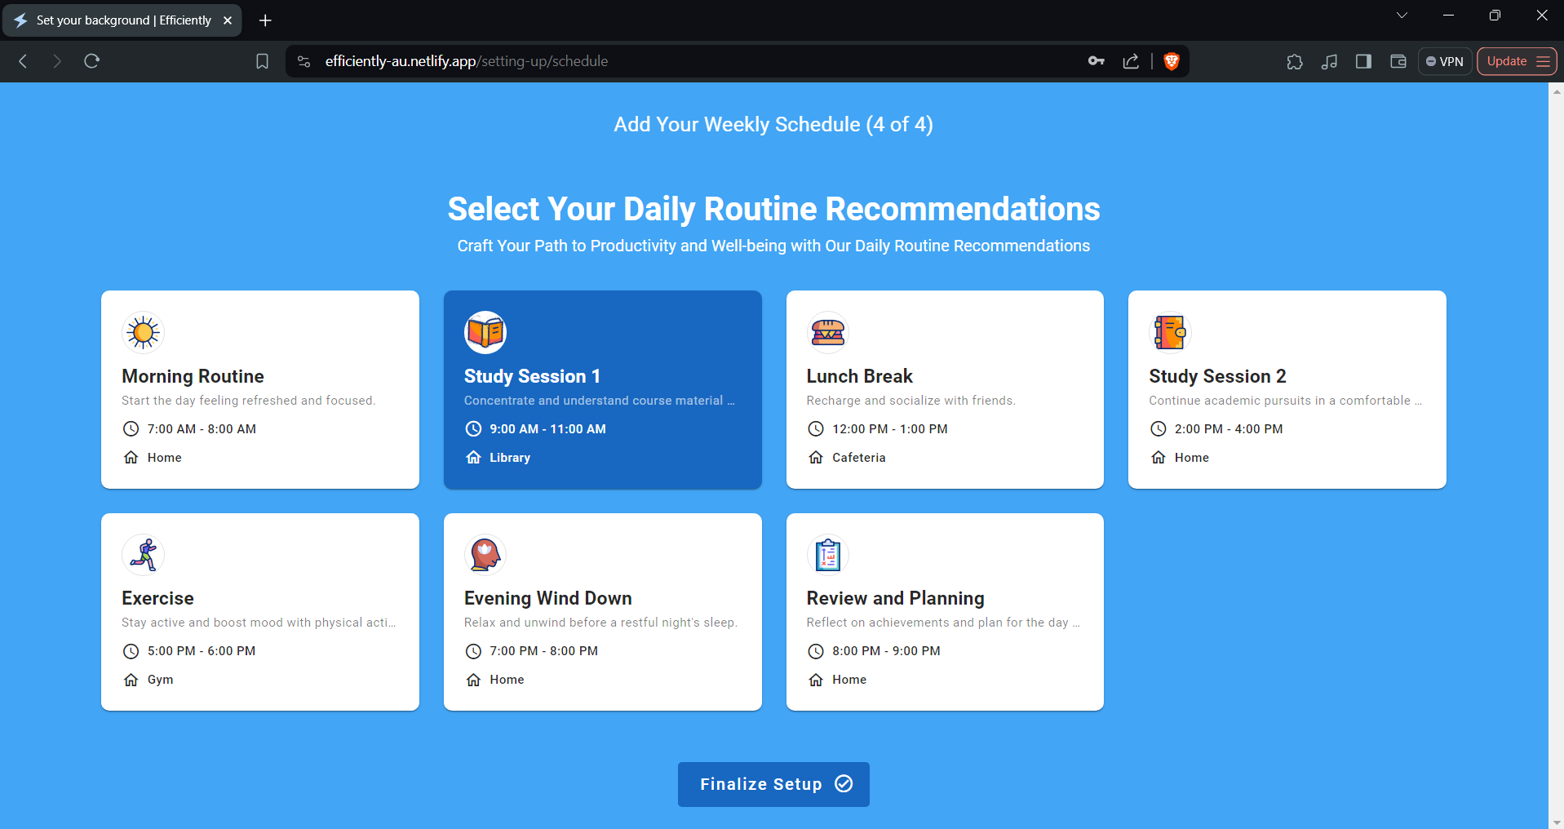

1. Congratulation you’re now setup. To continue click any.

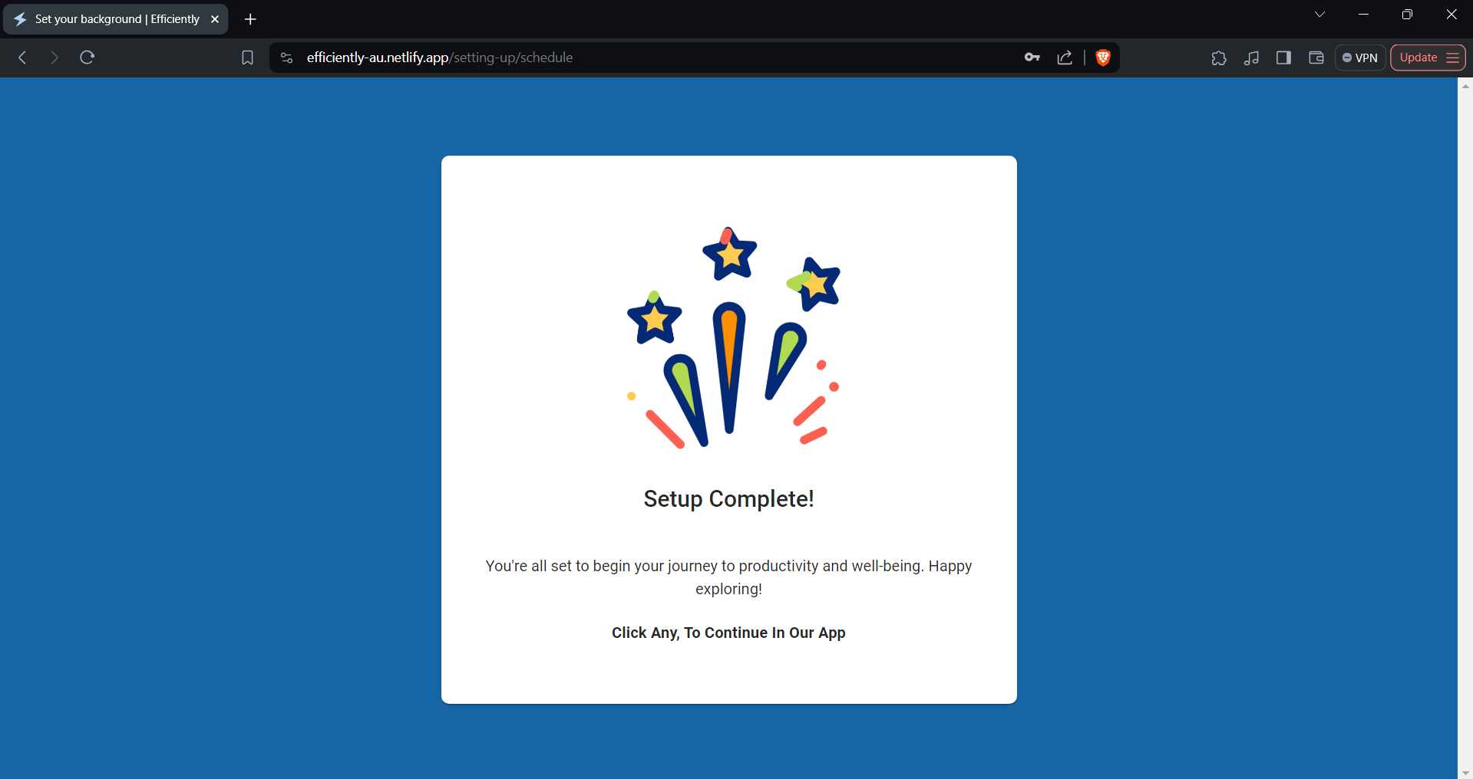

**Change Profile**

Allow you to control your edit your information, to get started you may follow the steps below.

1. Launch the application to your preferred web browser (like Chrome, Firefox, Safari, etc.) on your computer.
2. Locate the settings from the menu bar on the bottom right side of the screen.
3. Click the profile setting from the navigation bar. The picture below will show.

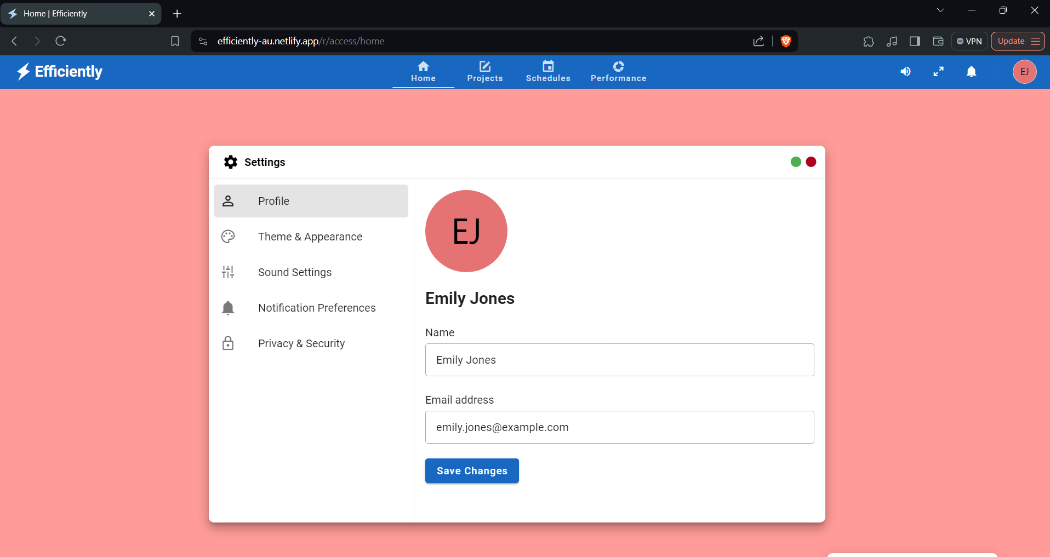

1. Fill up the name, and email field. Once you filled up, you may click save changes.

**Customization**

One of our powerful tool that allow you to customize the background, color, audio, and notification.

1. Launch the application to your preferred web browser (like Chrome, Firefox, Safari, etc.) on your computer.
2. Locate the settings from the menu bar on the bottom right side of the screen.

**Background Customization**

1. Click the theme and appearance from the navigation of settings.
2. Select preference background and color.

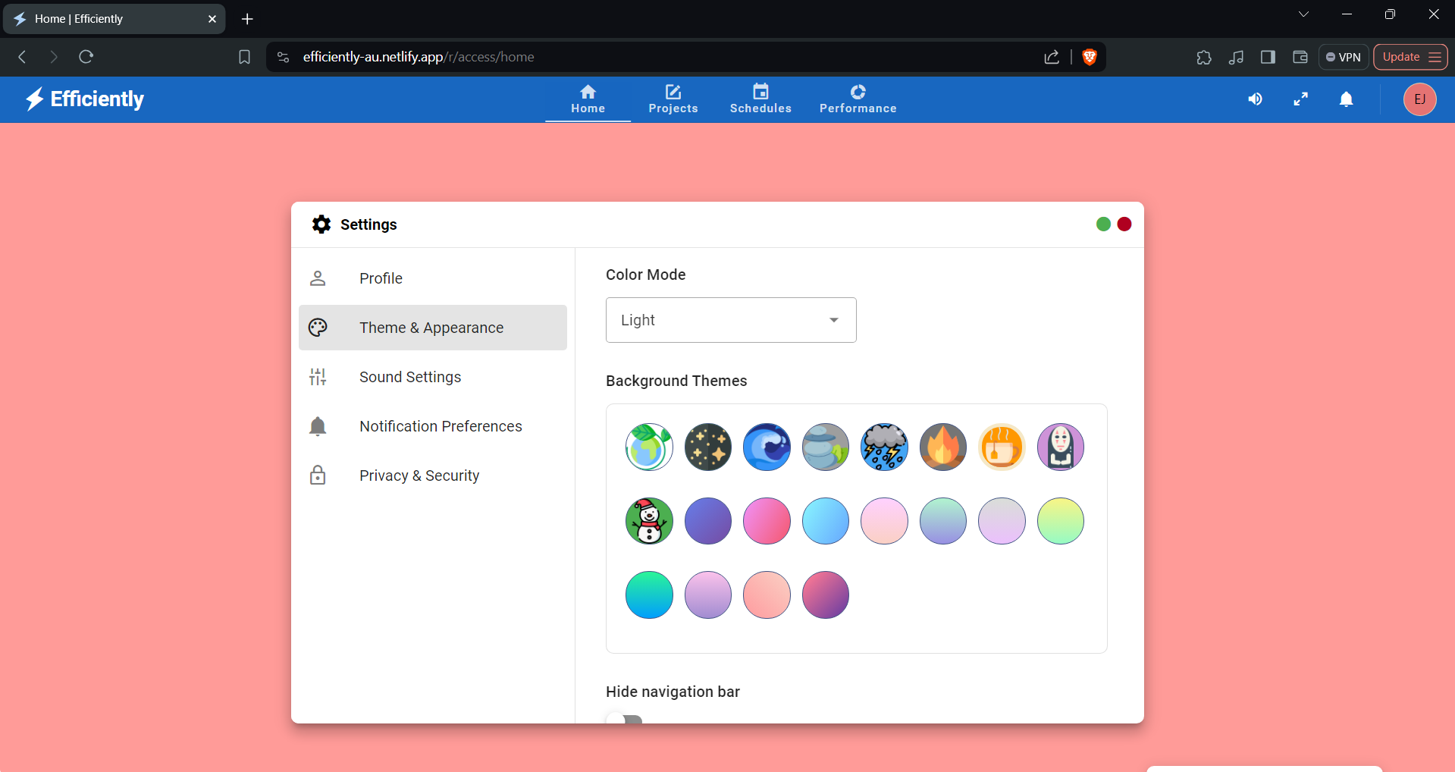

**Sound Customization**

1. Click the sound setting from the navigation of settings
2. Customize the sounds.

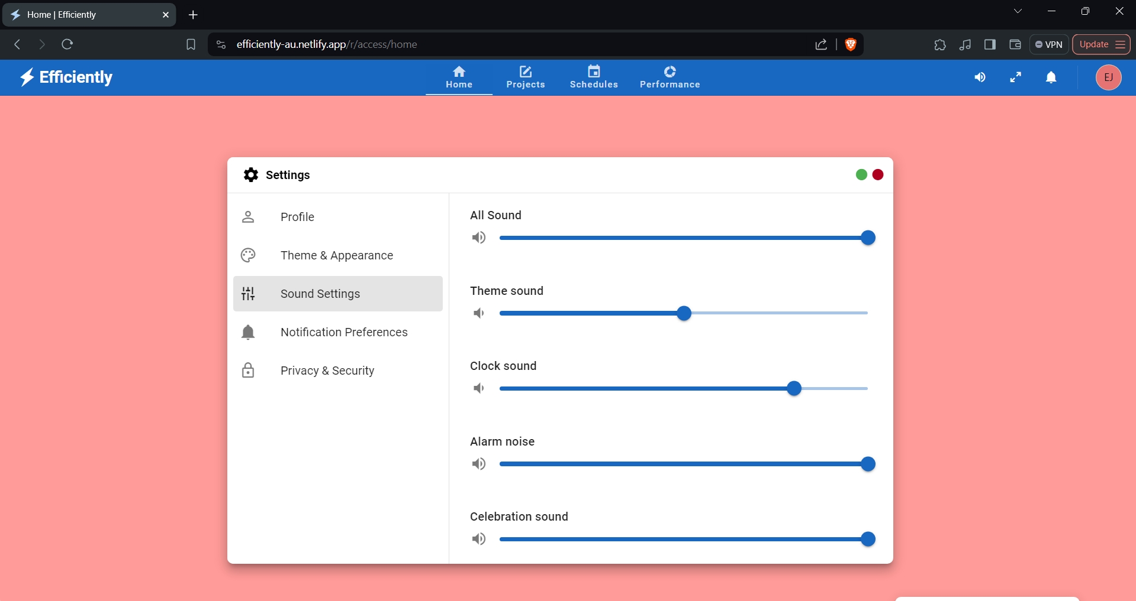

**Notification Customization**

1. Click the notification setting from the navigation of settings
2. 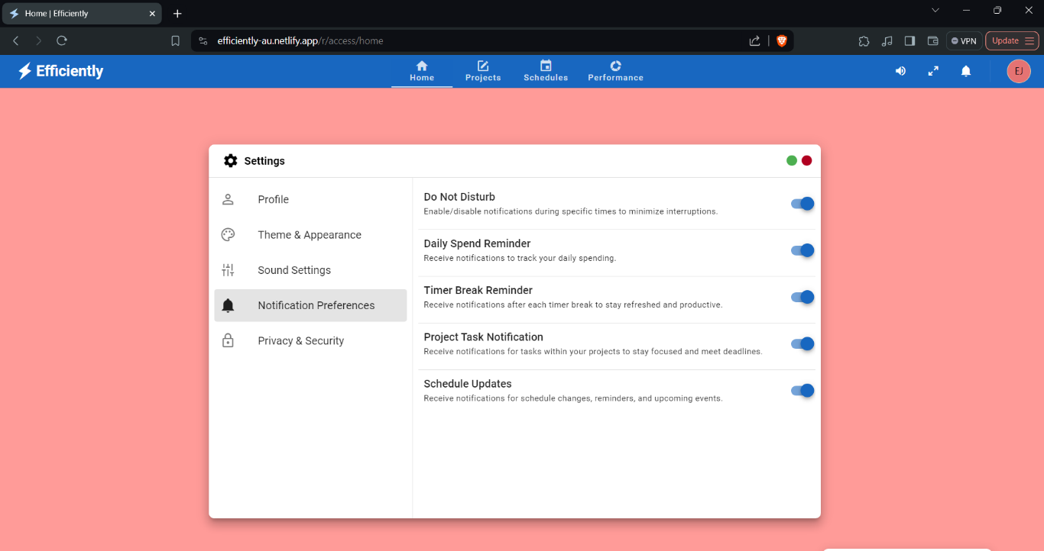Customize the notification.

**Security Guide**

Our security provide a change password that allow the user to prevent unauthorized access, monitoring your account browser session that protect your information, and a delete account to revoke their access and ensure the security and integrity of a system or platform.

To get started with security follow the steps.

1. Launch the application to your preferred web browser (like Chrome, Firefox, Safari, etc.) on your computer.
2. Locate the settings from the menu bar on the bottom right side of the screen.
3. Click the security and privacy from the navigation bar. You may see a browser session, change password, and delete account.

**Browser session -** Allow the user see all the session made to login in account, this is important to protect your information from the attacker. To remove the session or logout the session, you may click the logout other session button.

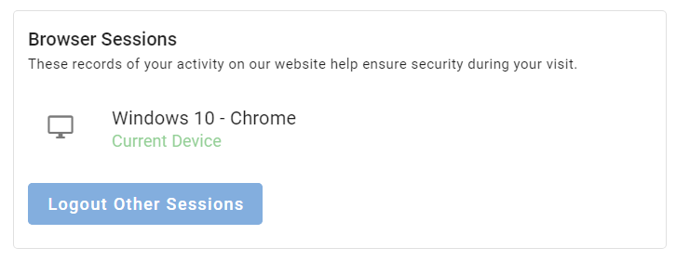

**Change password –** change passwordis important for security, preventing unauthorized access, and mitigating the risks of data breaches. To change the password you may fill up the current password, new password, and confirm password, to save you may click the save button.

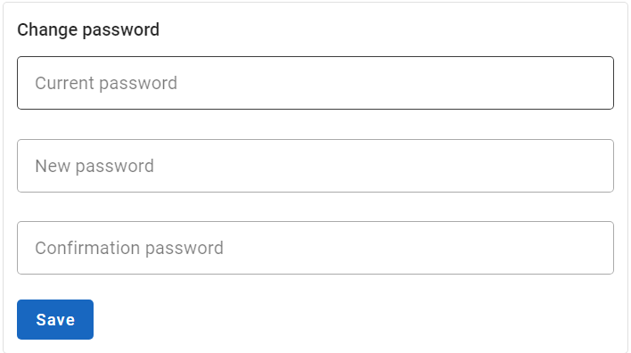

**Delete Account -** Deleting a user is important to revoke their access and ensure the security and integrity of a system or platform. To delete your account you may fill the email text field and click delete account.

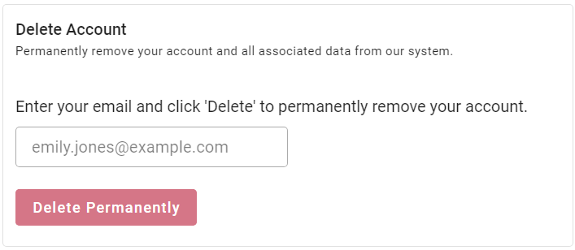

**Project Management Guide**

The project management allows the user to help organize their tasks. It also allows for collaboration with other users to create their own groups.

**How to use it?**

1. Navigate to the project management page. The output shown will be as follows:

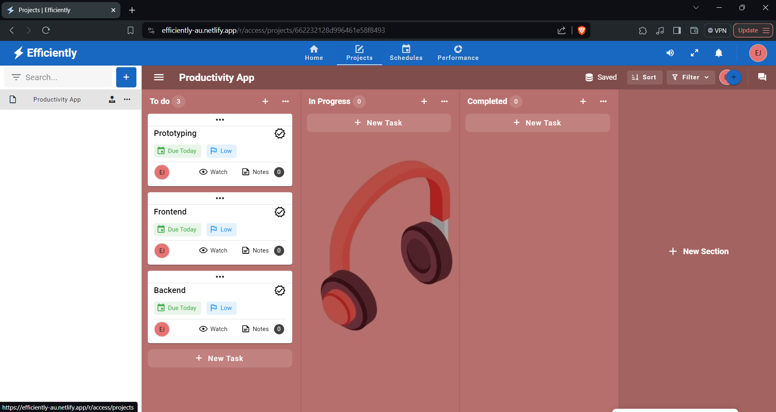

1. The section, the section indicate the status of the tasks inside of it. You may choose section or create new one.

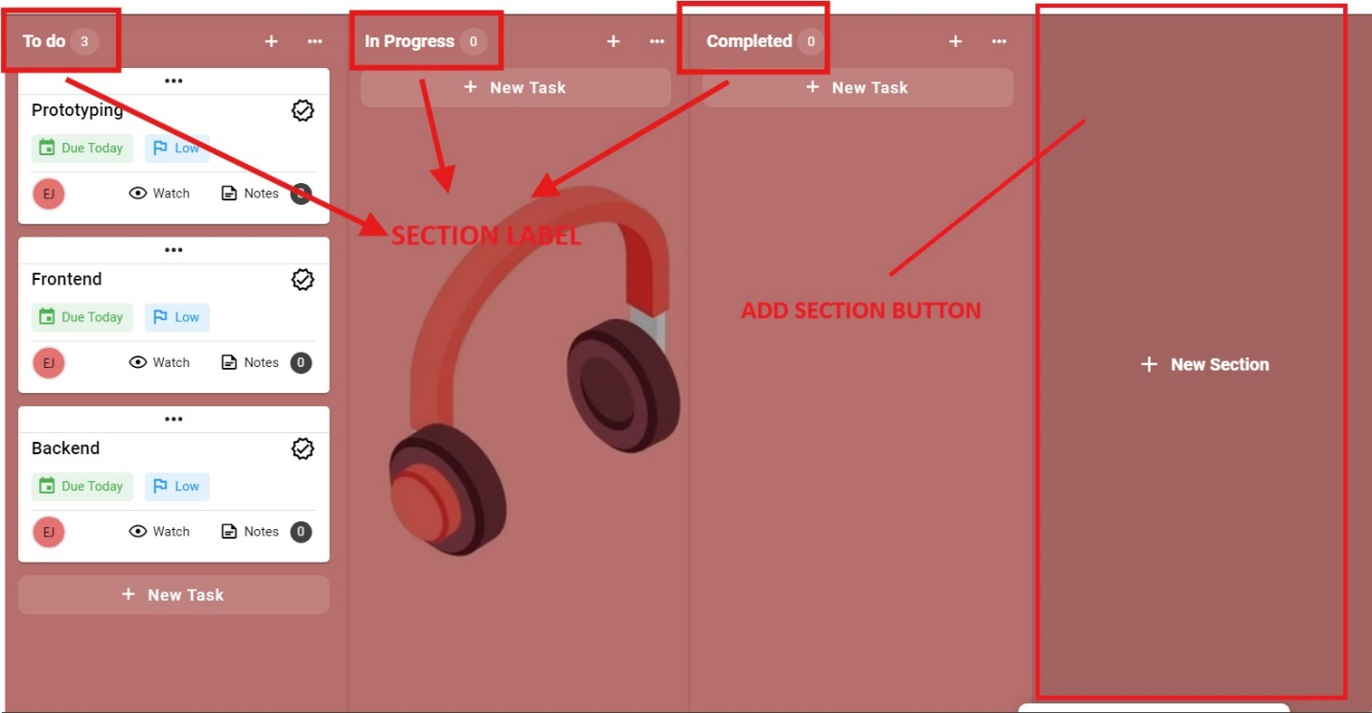

1. Once you select a section, select a task or create a new one.

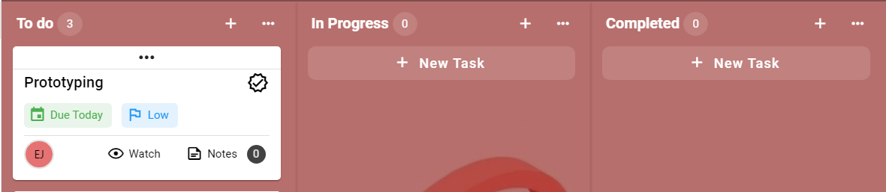

1. The task card is where the user see the details of the task such as the title, description, due date, priority, and assignees. You may select the task in current section or create a new one.
2. Once you select task you may edit the details such as title, description, priority status, and add assignees.
3. You may move the task to a section to indicate it status, such as the to do, in progress, and completed section.

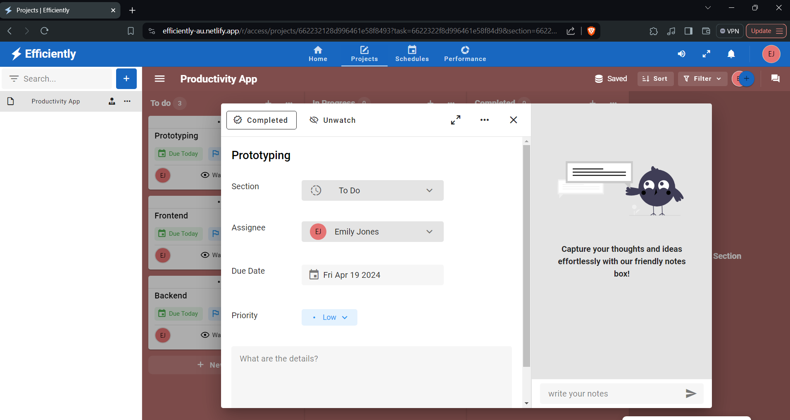

1. Congratulation you have successfully manage a simple tasks.

**Schedule Management Guide**

The schedule management is allow the user plan their daily, weekly, and monthly plan, to get started follow the steps below.

**How to use it?**

1. Navigate to the schedule management page
2. Select schedule or create a new one.

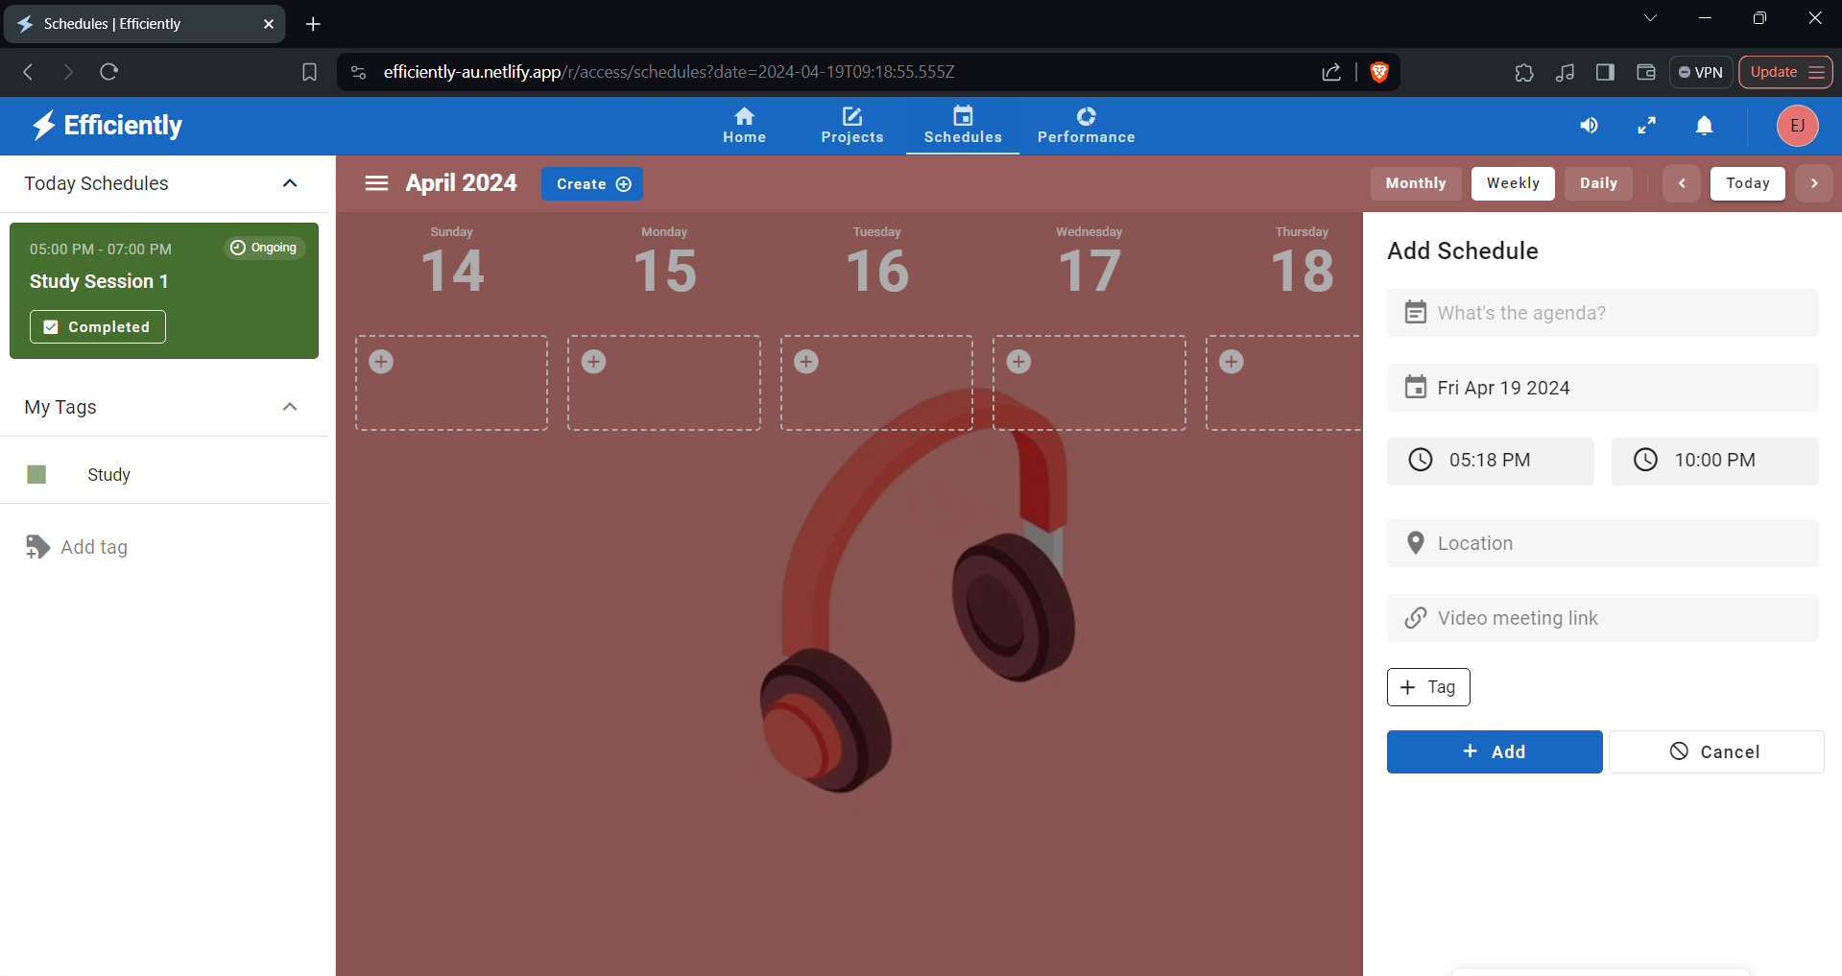

1. Once select a schedule, the schedule allow the user to put their plan or goal details, such as title, description, link, location, tags, time start, and time end.

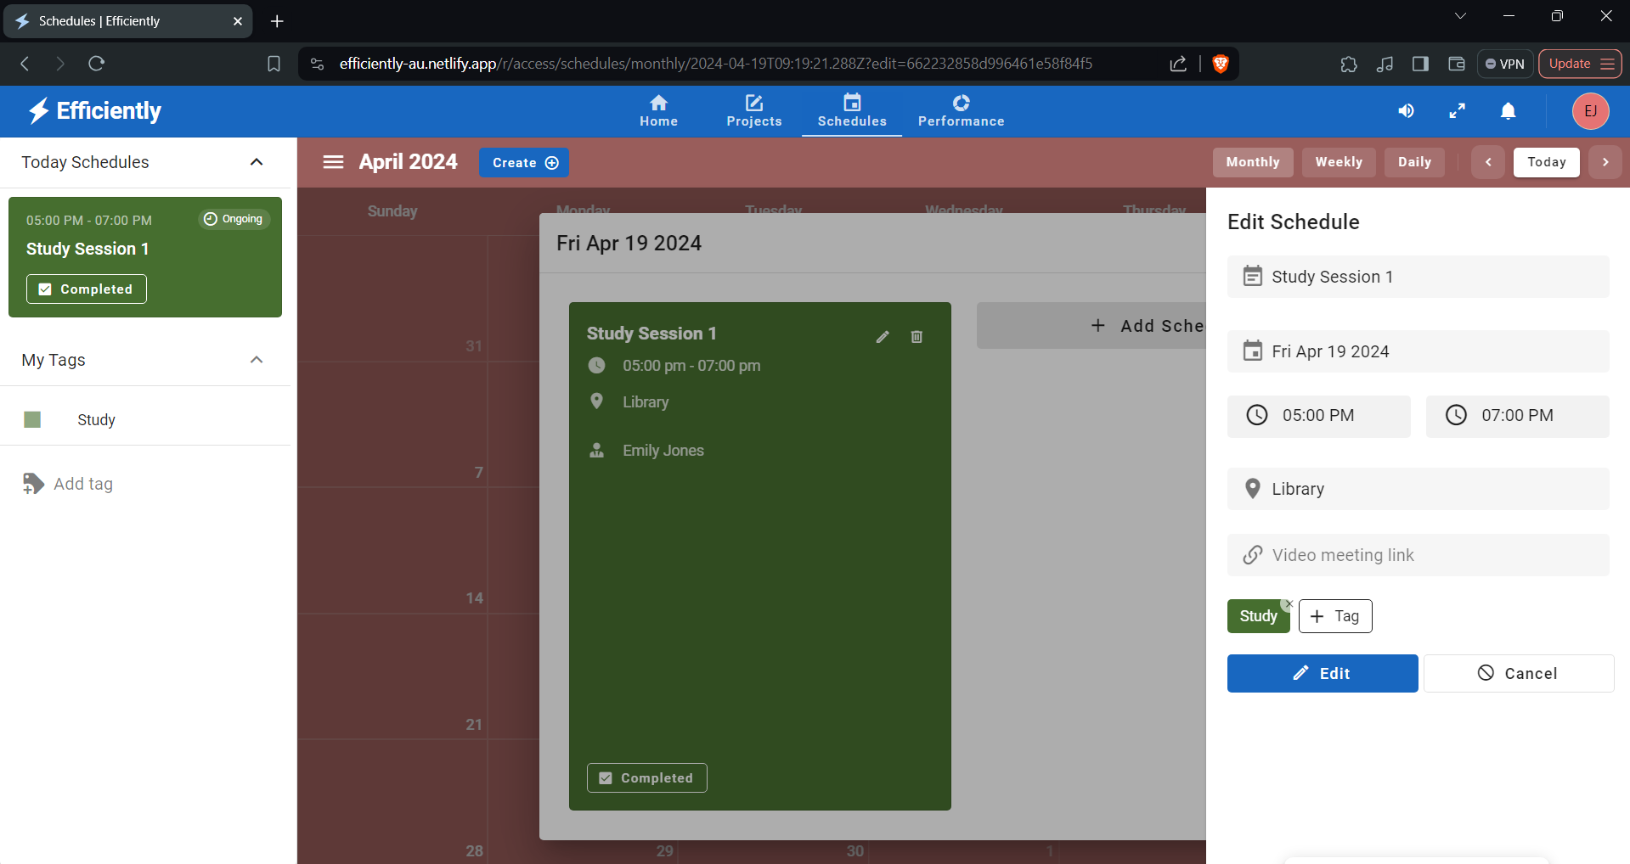

1. Once the schedule meet the goal or the plan he/she may mark the schedule as completed.
2. Congratulation you completed your goal.

**Appendix D**

**REFERENCES**

* UNESCO Office Santiago and Regional Bureau for Education in Latin America and the Caribbean. (2020). Education in the time of COVID-19 [Review of Education in the time of COVID-19]. COVID-19 Report ECLAC-UNESCO , 0000374075. https://unesdoc.unesco.org/ark:/48223/pf0000374075_eng
* What is Blended Learning? Examples & More. (n.d.). ELM Learning. https://elmlearning.com/hub/elearning/blended-learning/#:~:text=According%20to%20the%20International%20Society
* National University. (2021, November 23). Challenges of Distance Learning for Students. National University. https://www.nu.edu/blog/challenges-of-distance-learning-for-students/
* U.S. BUREAU OF LABOR STATISTICS. (n.d.). *What is Productivity? : U.S. Bureau of Labor Statistics*. Www.bls.gov. <https://www.bls.gov/k12/productivity-101/content/what-is-productivity/home.htm>
* Perry, E. (2023, March 23). *What is productivity? A complete guide for improving yours*. Www.betterup.com. https://www.betterup.com/blog/what-is-productivity
* Kenton, W. (2024, March 2). *Productivity*. Investopedia. https://www.investopedia.com/terms/p/productivity.asp
* Simplilearn. (2022, April 1). *What is Productivity? How to Define and Measure It? | Simplilearn*. Simplilearn.com. https://www.simplilearn.com/what-is-productivity-and-how-to-define-and-measure-it-article
* Holliday, M. (2021, April 13). *The Key to Productivity*. Oracle NetSuite. <https://www.netsuite.com/portal/resource/articles/business-strategy/productivity.shtml>
* Slack. (2021, September 12). *Top strategies for improving business productivity*. Slack. https://slack.com/blog/collaboration/top-strategies-improving-business-productivity
* *MindTools | Home*. (n.d.). Www.mindtools.com. https://www.mindtools.com/akxytki/keep-it-simple
* ReminderCall. (2023, January 25). *The Importance of Reminders in Achieving Goals | ReminderCall*. A Rectangle Health Company. https://www.remindercall.com/resources/role-of-reminders-in-achieving-goals/#:~:text=One%20of%20the%20significant%20ways
* *How Often Should I Review My Goals?* (n.d.). Www.habitify.me. Retrieved March 24, 2024, from https://www.habitify.me/blog/how-often-should-i-review-my-goals-daily-weekly#:~:text=In%20the%20end%2C%20to%20make
* *What is productivity software? - Definition from WhatIs.com*. (n.d.). WhatIs.com. https://www.techtarget.com/whatis/definition/productivity-software
* *9 Common Workplace Time-Wasters and How To Avoid Them*. (n.d.). Indeed Career Guide. https://www.indeed.com/career-advice/career-development/time-wasters-and-how-to-avoid-them
* FutureLearn. (2022, May 4). *How to be more productive: 10 productivity tips*. FutureLearn. https://www.futurelearn.com/info/blog/how-to-be-more-productive
* Laoyan, S. (2022, April 11). *The Importance of Setting Short-term Goals • Asana*. Asana. https://asana.com/resources/short-term-goals
* *The Importance of Taking Breaks*. (2019, September 5). The Wellbeing Thesis. https://thewellbeingthesis.org.uk/foundations-for-success/importance-of-taking-breaks-and-having-other-interests/#ref_4
* Perry, E. (2022, August 23). *The Importance of Taking Breaks: Increase Your Focus*. Www.betterup.com. https://www.betterup.com/blog/the-importance-of-taking-breaks
* Hakoune, R. (2019, August 16). *How to boost your productivity with time blocking*. Monday.com Blog. <https://monday.com/blog/productivity/increase-your-productivity-with-time-blocking-a-step-by-step-guide/>
* *Mastering Delegation: Boost Efficiency & Trust | 2023*. (2023, August 21). Northwest Executive Education. https://northwest.education/insights/careers/how-to-delegate-why-is-delegation-important/#:~:text=suited%20to%20them.-,Why%20is%20delegation%20important%3F,work%20on%20through%20your%20career.
* *The Importance of Removing Distractions in the Workplace*. (2019, April 25). Werqwise | Co-Working & Custom Office Spaces. https://werqwise.com/the-importance-of-removing-distractions-in-the-workplace/#:~:text=Distractions%20elevate%20stress%20levels%2C%20cause
* ‌Gautam, P. (2020, October 10). Advantages and disadvantages of online learning. ELearning Industry. <https://elearningindustry.com/advantages-and-disadvantages-online-learning>
* Martin, M. (2022, May 17). The Advantages and Disadvantages of Online Classes. Thinkific. <https://www.thinkific.com/blog/advantages-and-disadvantages-online-classes/>
* Top 10 Challenges of Online Learning As A Student | Amber. (2023, February 3). Amberstudent.com. <https://amberstudent.com/blog/post/top-10-challenges-of-online-learning-as-a-student>
* Zaitun, Z., Hadi, M. S., & Harjudanti, P. (2021). The Impact of Online Learning on the Learning Motivation of Junior High School Students. Bisma the Journal of Counseling, 5(1, 56. <https://doi.org/10.23887/bisma.v5i1.35980>
* Sellers, E. (2021). Poor Time Management in Online Learning. Education - Seattle PI. <https://education.seattlepi.com/poor-time-management-online-learning-1435.html>
* *Distractions: an obstacle to online education*. (2019, February 26). Observatory.tec.mx. https://observatory.tec.mx/edu-news/distraction-an-obstacle-to-online-education/
* Off Task During Online Learning: Kent State Study Finds Student Multitasking Increases in Online Courses Compared to Face-To-Face Courses | Kent State University. (n.d.). Www.kent.edu. <https://www.kent.edu/kent/news/kent-state-study-finds-student-multitasking-increases-online-courses>

**Appendix E**

**Attributes**

Title: Animated Icons Collection

1. Sunny Animated Icons

- Attribution: Freepik - Flaticon

- Link: [https://www.flaticon.com/free-animated-icons/sunny](https://www.flaticon.com/free-animated-icons/sunny)

2. Read Animated Icons

- Attribution: Freepik - Flaticon

- Link: [https://www.flaticon.com/free-animated-icons/read](https://www.flaticon.com/free-animated-icons/read)

3. Lunch Animated Icons

- Attribution: Freepik - Flaticon

- Link: [https://www.flaticon.com/free-animated-icons/lunch](https://www.flaticon.com/free-animated-icons/lunch)

4. Study Animated Icons

- Attribution: Freepik - Flaticon

- Link: [https://www.flaticon.com/free-animated-icons/study](https://www.flaticon.com/free-animated-icons/study)

5. Trail Running Animated Icons

- Attribution: Freepik - Flaticon

- Link: [https://www.flaticon.com/free-animated-icons/trail-running](https://www.flaticon.com/free-animated-icons/trail-running)

6. Calm Animated Icons

- Attribution: Freepik - Flaticon

- Link: [https://www.flaticon.com/free-animated-icons/calm](https://www.flaticon.com/free-animated-icons/calm)

7. Strategic Plan Animated Icons

- Attribution: Freepik - Flaticon

- Link: [https://www.flaticon.com/free-animated-icons/strategic-plan](https://www.flaticon.com/free-animated-icons/strategic-plan)

8. Confetti Animated Icons

- Attribution: Freepik - Flaticon

- Link: [https://www.flaticon.com/free-animated-icons/confetti](https://www.flaticon.com/free-animated-icons/confetti)

9. Celebrate Icons

- Attribution: Freepik - Flaticon

- Link: [https://www.flaticon.com/free-icons/celebrate](https://www.flaticon.com/free-icons/celebrate)

10. To Do List Icons

- Attribution: Freepik - Flaticon

- Link: [https://www.flaticon.com/free-icons/to-do-list](https://www.flaticon.com/free-icons/to-do-list)

11. Text Box Icons

- Attribution: Smashicons - Flaticon

- Link: [https://www.flaticon.com/free-icons/text-box](https://www.flaticon.com/free-icons/text-box)

12. Lightbulb Icons

- Attribution: Freepik - Flaticon

- Link: [https://www.flaticon.com/free-icons/lightbulb](https://www.flaticon.com/free-icons/lightbulb)

Title: Some Attributes

Attribution: Illustration by undraw.co

Link: <https://undraw.co/>

1. Nuxt.js:

- Framework for building Vue.js applications.

- Provides server-side rendering, static site generation, and single-page application capabilities.

- Offers a modular architecture and powerful features for rapid development.

- Integrates seamlessly with Vue.js ecosystem and libraries.

- Extensive documentation and active community support.

2. Vue.js:

- Progressive JavaScript framework for building user interfaces.

- Lightweight, flexible, and easy to learn.

- Employs a reactive data-binding mechanism and component-based architecture.

- Offers comprehensive tooling support, including Vue CLI for project scaffolding.

- Extensive ecosystem with plugins, components, and libraries for various functionalities.

3. Driven.js:

- JavaScript framework for building scalable and maintainable web applications.

- Focuses on convention over configuration and modular architecture.

- Emphasizes developer productivity, code quality, and scalability.

- Supports server-side rendering, client-side rendering, and static site generation.

- Integrates seamlessly with MongoDB and other databases.

4. MongoDB:

- NoSQL database that stores data in flexible, JSON-like documents.

- Highly scalable, distributed, and performance-oriented.

- Offers rich query language, indexing capabilities, and flexible data modeling.

- Supports sharding and replication for high availability and horizontal scaling.

- Widely used in modern web applications, microservices, and IoT platforms.

5. Netlify:

- Cloud platform for hosting and deploying modern web projects.

- Provides continuous deployment, automatic SSL, and global CDN.

- Integrates seamlessly with Git repositories for automated builds and deployments.

- Supports serverless functions, form handling, and identity management.

- Developer-friendly interface, CLI, and extensive documentation.

6. Render:

- Scalable cloud platform for hosting web applications and static sites.

- Offers automatic scaling, continuous deployment, and HTTPS by default.

- Supports Docker containers, serverless functions, and background jobs.

- Provides built-in monitoring, logging, and alerting for applications.

- Simplified pricing model with no hidden fees and pay-as-you-go billing.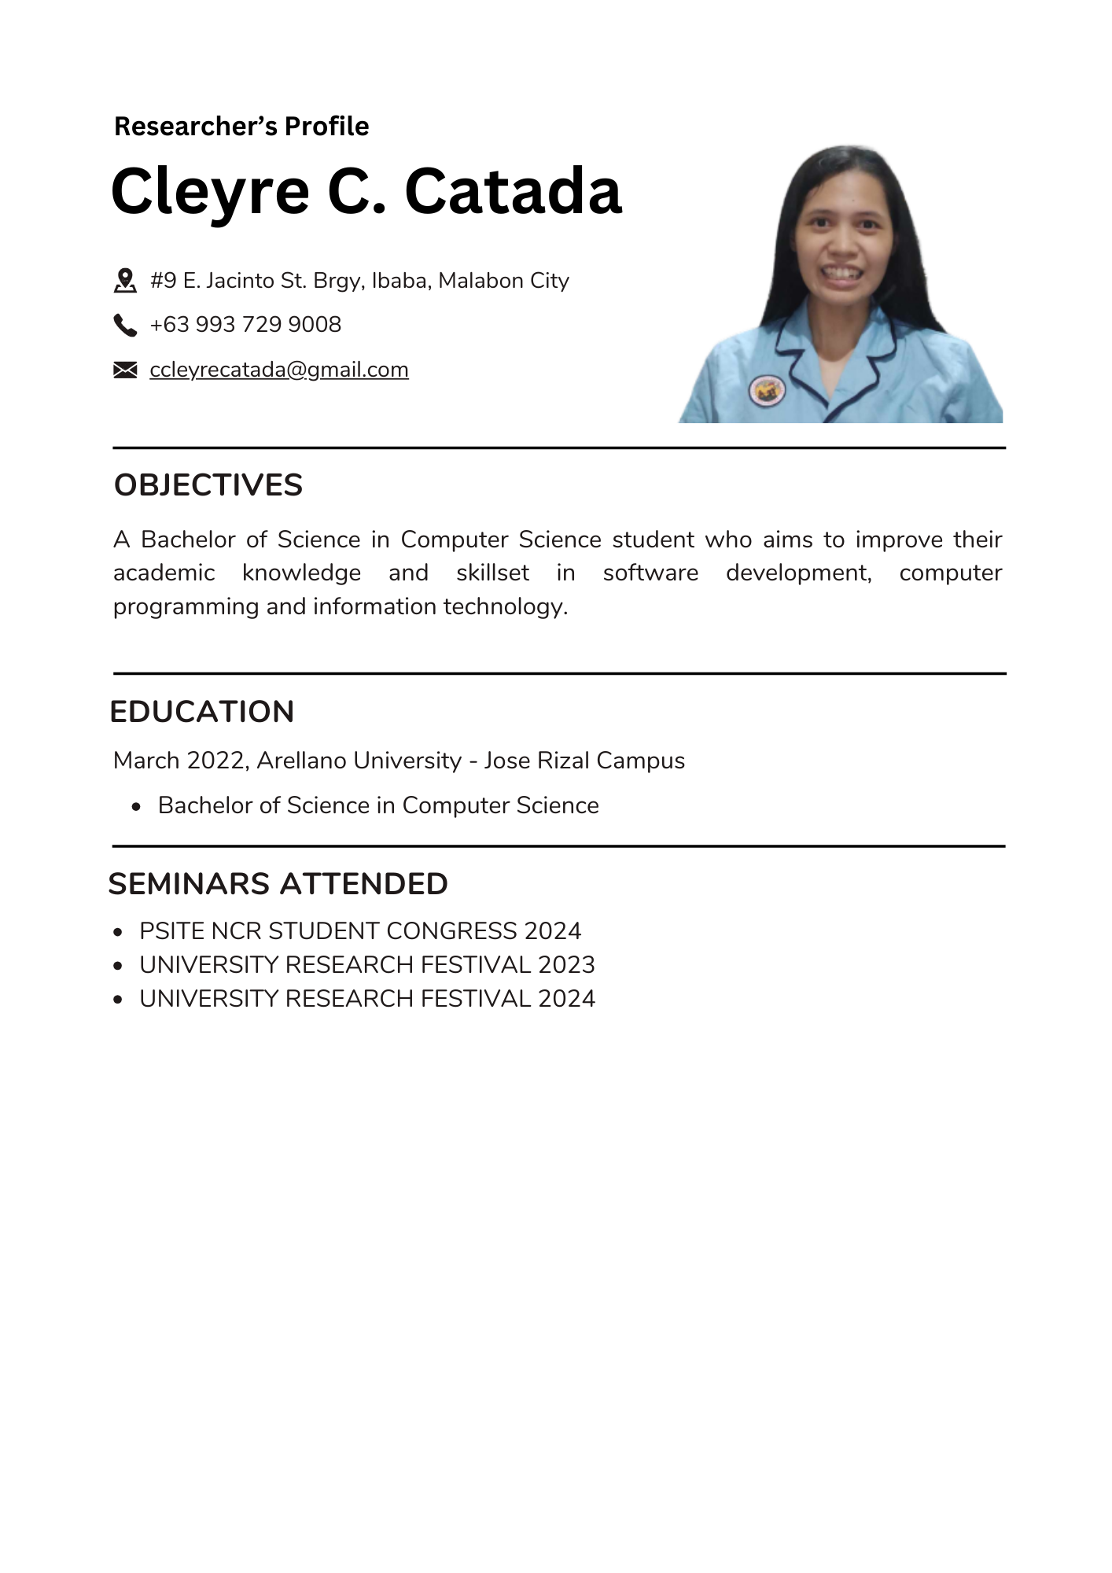**Appendix F**

**Group Curriculum Vitae**

